# Instructional Guide to Support 2023 Grade 3 Mathematics *Standards of Learning*



Copyright © 2025

by the

Virginia Department of Education

P.O. Box 2120

Richmond, Virginia 23218-2120

[http://www.doe.virginia.gov](http://doe.virginia.gov/)

All rights reserved. Reproduction of these materials for instructional purposes in public school classrooms in Virginia is permitted.

**Superintendent of Public Instruction**

Emily Anne Gullickson, M.Ed. J.D.

**Office of Math and Science**

Dr. Anne Petersen, Director of Math and Science

Dr. Angela Byrd-Wright, Director of Humanities (Former Mathematics Coordinator)

Ms. Victoria Bohidar, Mathematics Coordinator

Dr. Jessica Brown, Elementary Mathematics Specialist

Dr. Regina Mitchell, Mathematics and Special Education Specialist

Mrs. Donna Snyder, Mathematics Division Support Specialist

**NOTICE**

The Virginia Department of Education does not unlawfully discriminate on the basis of race, color, sex, national origin, age, or disability in employment or in its educational programs or services.

Table of Contents

Introduction 2

Understanding the Standard 2

Skills in Practice 2

Concepts and Connections 2

Number and Number Sense 3

3.NS.1 3

3.NS.2 7

3.NS.3 10

3.NS.4 18

Computation and Estimation 22

3.CE.1 22

3.CE.2 32

Measurement and Geometry 42

3.MG.1 42

3.MG.2 46

3.MG.3 50

3.MG.4 53

Probability and Statistics 59

3.PS.1 59

Patterns, Functions, and Algebra 66

3.PFA.1 66

## Introduction

The Mathematics Instructional Guide, a companion document to the 2023 Mathematics *Standards of Learning*, amplifies the Standards of Learning by defining the core knowledge and skills in practice, supporting teachers and their instruction, and serving to transition classroom instruction from the 2016 *Mathematics Standards of Learning* to the newly adopted 2023 Mathematics *Standards of Learning.* Instructional supports are accessible in #GoOpenVA and support the decisions local school divisions must make concerning local curriculum development and how best to help students meet the goals of the standards. The local curriculum should include a variety of information sources, readings, learning experiences, and forms of assessment selected at the local level to create a rigorous instructional program.

For a complete list of the changes by standard, the [2023 Virginia Mathematics *Standards of Learning – Overview of Revisions*](https://www.doe.virginia.gov/home/showpublisheddocument/49329/638325360068970000) is available and delineates in greater specificity the changes for each grade level and course.

The Instructional Guide is divided into three sections: Understanding the Standard, Skills in Practice, and Concepts and Connections aligned to the Standard. The purpose of each is explained below.

### Understanding the Standard

This section includes mathematics understandings and key concepts that assist teachers in planning standards-focused instruction. The statements may provide definitions, explanations, or examples regarding information sources that support the content. They describe what students should know (core knowledge) as a result of the instruction specific to the course/grade level and include evidence-based practices to approaching the Standard. There are also possible misconceptions and common student errors for each standard to help teachers plan their instruction.

### Skills in Practice

This section outlines supporting questions and skills that are specifically linked to the standard. They frame student inquiry, promote critical thinking, and assist in learning transfer. Curriculum writers and teachers should use them to plan instruction to deepen understanding of the broader unit and course objectives. This is not meant to be an exhaustive list of student expectations.

### Concepts and Connections

This section outlines concepts that transcend grade levels and thread through the K through 12 mathematicsprogram as appropriate at each level. Concept connections reflect connections to prior grade-level concepts as content and practices build within the discipline as well as potential connections across disciplines.

# Grade 3

## Number and Number Sense

In K-12 mathematics, numbers and number sense form the foundation building blocks for mathematics understanding. Students develop a foundational understanding of numbers, their properties, and the relationships between them as they learn to compare and order numbers, understand place value, and perform numerical operations. Number sense includes an understanding of patterns and the relationships between numbers and being able to apply this knowledge to real world problems. Throughout K-12, students build on their number sense to develop a deeper understanding of mathematical concepts and reasoning.

In Grade 3, students will demonstrate flexibility with composing and decomposing base 10 numbers and understanding the structure to build relationships among numbers allows them to quantify, measure, and make decisions in life. At this grade level, students will read, write, and determine the place and value of each digit in a whole number (up to six digits); compare and order whole numbers up to 9,999; represent and compare fractions (proper, improper, or mixed numbers with denominators of 2, 3, 4, 5, 6, 8, and 10); and count, compare, represent, and make change for money amounts up to $5.00.

### 3.NS.1

##### The student will use place value understanding to read, write, and determine the place and value of each digit in a whole number, up to six digits, with and without models.

1. Students will demonstrate the following Knowledge and Skills:
2. Read and write six-digit whole numbers in standard form, expanded form, and word form.
3. Apply patterns within the base 10 system to determine and communicate, orally and in written form, the place and value of each digit in a six-digit whole number (e.g., in 165,724, the 5 represents 5 thousands and its value is 5,000).
4. Compose, decompose, and represent numbers up to 9,999 in multiple ways, according to place value (e.g., 256 can be 1 hundred, 14 tens, 16 ones, but also 25 tens, 6 ones), with and without models.

###### Understanding the Standard

* Experiences that relate to practical situations in students’ environments should be provided so that the reading and writing of large numbers becomes meaningful (e.g., the population of the school versus the school division, the number of seats in an auditorium versus a stadium, the number of letters in a word versus on a page).
* Numbers are arranged into groups of three places called *periods* (ones, thousands, millions, etc.). Places within the periods repeat (hundreds, tens, ones). Commas are used to separate the periods. Knowing the place value and period of a number helps students read and write numbers and determine the value of a digit in any number.
* The structure of the base 10 number system is based upon a pattern of tens, where each place is ten times the value of the place to its right.
* Place value refers to the value of each digit and depends upon the position (place) of the digit in the number. In the number 7,864, the 8 is in the hundreds place, and the value of the 8 is eight hundred.
* Whole numbers may be written in a variety of formats, including:
  + standard: 123,456;
  + word or written: one hundred twenty-three thousand, four hundred fifty-six;
  + expanded: 100,000 + 20,000 + 3,000 + 400 + 50 + 6; or (1 x 100,000) + (2 x 10,000) + (3 x 1,000) + (4 x 100) + (5 x 10) + (6 x 1).
* Concrete materials that clearly illustrate the relationships among hundreds, tens, and ones, and are physically proportional (e.g., the tens piece is ten times larger than the ones piece) may be used to represent whole numbers. When moving beyond concrete representations, non-proportional manipulatives such as number disks (e.g., 1, 10, 100, 1000) can be helpful in developing place value understanding of larger numbers.
* The ability to rename and think flexibly about numbers enhances a student's ability to make sense of algorithms. Decomposition of numbers in a variety of ways (e.g., 2,345 is 23 hundreds, 4 tens, and 5 ones; or 2 thousands, 34 tens, and 5 ones; or 22 hundreds, 13 tens, and 15 ones) supports understandings essential to the operations of addition/subtraction and multiplication/division. This flexibility builds background understanding for the ideas that students use when regrouping (e.g., when subtracting 18 from 174, a student may choose to regroup and think of 174 as 1 hundred, 6 tens, and 14 ones, while another student might regroup 174 as 1 hundred, 5 tens, and 24 ones, then subtract 18 from 24).

###### Skills in Practice

While the five process goals are expected to be embedded in each standard, the Skills in Practice highlight the most prevalent process goals in relation to the content presented.

**Mathematical Connections:** Students may have difficulty translating a number from one form to another.

* Translating a number from word form to standard form, especially when zero is in one or more place value positions in the number (e.g., seven hundred sixty thousand, four hundred eight), can present a challenge for some students. The use of a place value chart, as shown below, may help students write numbers in standard form. In addition, students would benefit from explicit instruction connecting the conventions used in word form (e.g., commas separating the periods) to the attributes of a number in standard form (e.g., three digits in each period, commas separating the periods). Understanding these connections can help students break the word form of a number into meaningful “chunks” as they translate it into standard form.

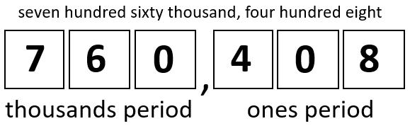

* Translating a number from expanded form, when the number is not presented in order, to standard or word form may be challenging for students. For example, given the number 5,000 + 30,000 + 200 + 7 + 80, a student may write the number in standard form as 53,278. This indicates that the student is not able to differentiate between the different place values of a number. Using concrete manipulatives (e.g., base 10 blocks) and beginning with two-, three-, or four-digit numbers presented “out of order” before extending to larger numbers may be helpful for students. As students extend to larger numbers, the use of a place value mat or chart may help students organize their work.

**Mathematical Representations:** Students may have difficulty representing numbers in multiple ways. For example, given the number 354, a student may not recognize that 354 can be represented as 3 hundreds, 5 tens, and 4 ones, but can also be represented as 2 hundreds, 15 tens, and 4 ones; or as 3 hundreds, 4 tens, and 14 ones. (See the example below.) Students who make this error would benefit from additional experiences with trading activities using base 10 blocks or other manipulatives that provide opportunities to represent the same number in more than one way. Students may also benefit from beginning with two-digit numbers and then extending to three- and four-digit numbers.

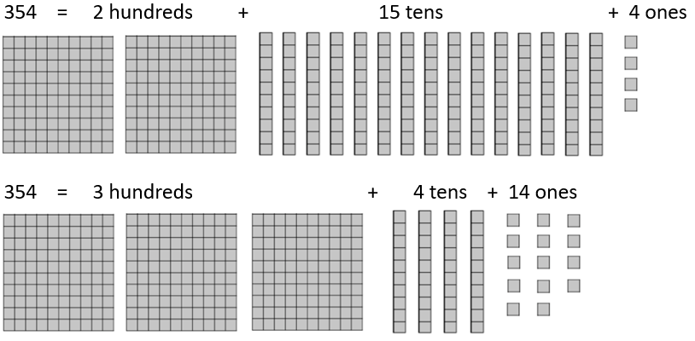

###### Concepts and Connections

Concepts

Flexibility with composing and decomposing base 10 numbers and understanding the structure to build relationships among numbers allows us to quantify, measure, and make decisions in life.

Connections

* *Within the grade level/course*:
  + 3.NS.2 – The student will demonstrate an understanding of the base 10 system to compare and order whole numbers up to 9,999.
  + 3.CE.1 – The student will estimate, represent, solve, and justify solutions to single-step and multistep problems, including those in context, using addition and subtraction with whole numbers where addends and minuends do not exceed 1,000.
* *Vertical Progression*:
  + 2.NS.2 – The student will demonstrate an understanding of the ten-to-one relationships of the base 10 number system to represent, compare, and order whole numbers up to 999.
  + 4.NS.1 – The student will use place value understanding to read, write, and identify the place and value of each digit in a nine-digit whole number.

Across Content Areas [Theme – Numbers, Number Sense, and Patterns]

* *Computer Science*:
  + 3.AP.1 – The student will apply computational thinking to design algorithms to extend patterns, processes, or components of a problem.
    - a) Identify a pattern in an algorithm, process, or a problem.
    - b) Decompose a problem or task into a subset of smaller problems.
    - c) Design an algorithm to extend either a pattern, process, or component of a problem.
  + 3.DA.2 – The student will create and evaluate data representations and conclusions.
    - b) Analyze data to identify patterns, draw conclusions, and make predictions.

###### Resources to Support Local Curriculum

* A list of approved textbooks and instructional materials is posted on the VDOE [website](https://www.doe.virginia.gov/teaching-learning-assessment/k-12-standards-instruction/mathematics/2024-mathematics-textbooks).
* Place Value Exemplar Mathematics Instructional Plan ([Word](https://www.doe.virginia.gov/home/showpublisheddocument/51765/638398745948400000) | [PDF](https://www.doe.virginia.gov/home/showpublisheddocument/51767/638398745954500000))
* Place Value Games Exemplar Mathematics Instructional Plan ([Word](https://www.doe.virginia.gov/home/showpublisheddocument/51769/638421246319970000) | [PDF](https://www.doe.virginia.gov/home/showpublisheddocument/51771/638421246633570000))
* Place Value Mat Activities Exemplar Mathematics Instructional Plan ([Word](https://www.doe.virginia.gov/home/showpublisheddocument/51773/638398745970100000) | [PDF](https://www.doe.virginia.gov/home/showpublisheddocument/51775/638398745975570000))

### 3.NS.2

##### The student will demonstrate an understanding of the base 10 system to compare and order whole numbers up to 9,999.

1. Students will demonstrate the following Knowledge and Skills:
2. Compare two whole numbers, each 9,999 or less, using symbols (>, <, =, ≠) and/or words (*greater than*, *less than*, *equal to*, *not equal to*), with and without models.
3. Order up to three whole numbers, each 9,999 or less, represented with and without models, from least to greatest and greatest to least.

###### Understanding the Standard

* The ten-to-one place value relationship of numbers is helpful when comparing and ordering numbers.
* Numbers written in standard form are often more easily compared. Students are then able to use the number of digits in a whole number, and the place and value of those digits, to compare and order numbers.
* Numbers written in expanded form are also easy to compare, as the value of each digit in each place value is written out.
* A number line is one model that can be used when comparing and ordering numbers.
* Mathematical symbols (>, <) used to compare two unequal numbers are called inequality symbols. The equal symbol (=) means that the values on either side are equivalent (balanced). The not equal (≠) symbol means that the values on either side are not equivalent (not balanced).

###### Skills in Practice

While the five process goals are expected to be embedded in each standard, the Skills in Practice highlight the most prevalent process goals in relation to the content presented.

**Mathematical Problem Solving:** The most common error made by students when ordering a set of numbers from least to greatest is putting the numbers in order from greatest to least. These students may demonstrate an understanding of ordering numbers but would benefit from strategies that focus attention on the type of ordering required.

**Mathematical Reasoning:** Students may have difficulty comparing larger numbers with different numbers of digits. For example, given the numbers 979 and 1,102, students may state that 979 is larger than 1,102. These students incorrectly reason that because the digit 9 is in the highest place value of a number (the 9 in the hundreds place), it automatically makes the number greater than another number that has a higher place value (the 1 in the thousands place). Using manipulatives such as place value blocks to demonstrate this concept using smaller numbers (e.g., 121 is greater than 97) may help students strengthen their place value understanding. The use of a place value chart may also provide a helpful visual aid for comparing the individual digits between two numbers, as shown in the image below.

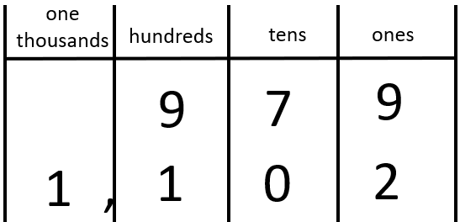

**Mathematical Representations:** Some students will likely confuse the < and > symbols and use them incorrectly when comparing numbers. Often, these students will be able to determine which number is greater and which number is less, but they are unsure of which symbol should be used to make the number sentence correct. Students would benefit from additional practice reading these comparisons aloud to make sure the correct vocabulary is used with the correct symbol.

###### Concepts and Connections

Concepts

Flexibility with composing and decomposing base 10 numbers and understanding the structure to build relationships among numbers allows us to quantify, measure, and make decisions in life.

Connections

* *Within the grade level/course*:
  + 3.NS.1 – The student will use place value understanding to read, write, and determine the place and value of each digit in a whole number, up to six digits, with and without models.
* *Vertical Progression*:
  + 2.NS.2 – The student will demonstrate an understanding of the ten-to-one relationships of the base 10 number system to represent, compare, and order whole numbers up to 999.
  + 4.NS.2 – The student will demonstrate an understanding of the base 10 system to compare and order whole numbers up to seven digits.

Across Content Areas

Reference 3.NS.1.

###### Resources to Support Local Curriculum

* A list of approved textbooks and instructional materials is posted on the VDOE [website](https://www.doe.virginia.gov/teaching-learning-assessment/k-12-standards-instruction/mathematics/2024-mathematics-textbooks).
* Comparing and Ordering Numbers Exemplar Mathematics Instructional Plan ([Word](https://www.doe.virginia.gov/home/showpublisheddocument/51777/638398745981370000) | [PDF](https://www.doe.virginia.gov/home/showpublisheddocument/51779/638398745987600000))

### 3.NS.3

##### The student will use mathematical reasoning and justification to represent and compare fractions (proper and improper) and mixed numbers with denominators of 2, 3, 4, 5, 6, 8, and 10), including those in context.

1. Students will demonstrate the following Knowledge and Skills:
2. Represent, name, and write a given fraction (proper or improper) or mixed number with denominators of 2, 3, 4, 5, 6, 8, and 10 using:
   1. region/area models (e.g., pie pieces, pattern blocks, geoboards);
   2. length models (e.g., paper fraction strips, fraction bars, rods, number lines); and
   3. set models (e.g., chips, counters, cubes).
3. Identify a fraction represented by a model as the sum of unit fractions.
4. Use a model of a fraction greater than one to count the fractional parts to name and write it as an improper fraction and as a mixed number (e.g., , , , , = 1 ).
5. Compose and decompose fractions (proper and improper) with denominators of 2, 3, 4, 5, 6, 8, and 10 in multiple ways (e.g., = + or = + = + ) with models.
6. Compare a fraction, less than or equal to one, to the benchmarks of 0, , and 1 using area/region models, length models, and without models.
7. Compare two fractions (proper or improper) and/or mixed numbers with like numerators of 2, 3, 4, 5, 6, 8, and 10 (e.g., > ) using words (*greater than, less than*, *equal to*) and/or symbols (>, <, =), using area/region models, length models, and without models.
8. Compare two fractions (proper or improper) and/or mixed numbers with like denominators of 2, 3, 4, 5, 6, 8, and 10 (e.g., <) using words (*greater than, less than*, *equal to*) and/or symbols (>, <, =), using area/region models, length models, and without models.
9. Represent equivalent fractions with denominators of 2, 3, 4, 5, 6, 8, or 10, using region/area models and length models.

###### Understanding the Standard

* A fraction is a numerical way of representing part of a whole. Fractions can have different meanings: part-whole, measurement, division, ratio, and operator. When working with fractions, the whole must be defined. In Grade 3, fractions most commonly represent part-whole or measurement situations.
* The value of a fraction  is dependent on both *b,* the number of equivalent parts in a whole (denominator), and *a,* the number of those parts being considered (numerator).
* A unit fraction is a fraction with a numerator of one (e.g., ).
* Proper fractions, improper fractions, and mixed numbers are terms often used to describe fractions. A proper fraction is a fraction that is less than one whole (i.e., a fraction with a numerator that is less than the denominator). An improper fraction is a fraction that is greater than or equal to one whole (i.e., a fraction with a numerator that is greater than or equal to the denominator). An improper fraction may also be expressed as a mixed number. A mixed number is written with two parts: a whole number and a proper fraction. The value of a mixed number is the sum of its two parts.
* Students should have opportunities to use models to count fractional parts that go beyond one whole. As a result of building the whole while they are counting, students will begin to generalize that when the numerator and the denominator are the same, there is one whole and when the numerator is larger than the denominator, there is more than one whole. They also will begin to see a fraction as the sum of unit fractions (e.g., three-fourths is the same as three one-fourths or six-sixths is the same as six one-sixths, which is equal to one whole). This provides students with a visual, as in the example below, for when one whole is reached and helps students develop a greater understanding of the relationship between the numerator and denominator.

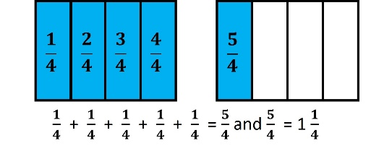

* Representations that students use in fraction explorations, activities, and during problem-solving help to develop specific fraction concepts. At this grade level, the three representations most used are region/area models, set models, or length/measurement models.
* In a region/area model (e.g., pie pieces, pattern blocks, geoboards, drawings), the whole is divided or partitioned into parts with areas of equivalent value. The region/area model is helpful with visualizing and understanding the part-whole relationship. The fractional parts are not always congruent and could have a different shape as shown in the middle example below:

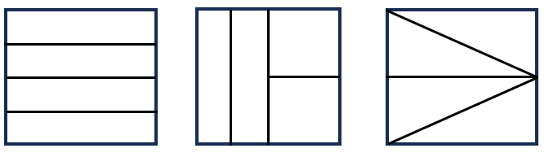

* In a set model (e.g., chips, counters, cubes, drawings), the model is made up of discrete members of the set, where each member is an equivalent part of the set. The set model may be challenging for students who demonstrate limited understanding of the part-whole relationship. In set models, the whole needs to be defined, but members of the set may have different sizes and shapes. For example, if a whole is defined as a set of 10 shapes, the shapes within the set may be different. In the example below, stars represent of the set:

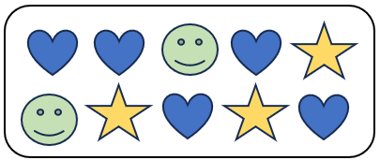

* In a length/measurement model (e.g., rods, connecting cubes, number lines, rulers, and drawings), each length represents an equal part of the whole. For example, given a narrow strip of paper, students could fold the strip into four equal parts, with each part representing one-fourth. Students will notice that there are four one-fourths in the entire length of the strip of paper that has been divided into fourths. Connecting a concrete or pictorial model to a representation of a number line helps students to make sense of the spaces that show the value of the fraction as shown below.

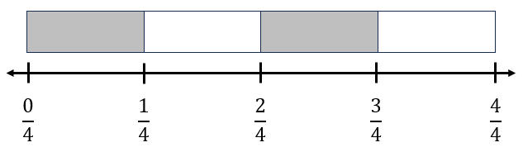

* A ruler is an important representation of the length model of fractions. When using rulers to measure length, students can make a connection to fractions and mixed numbers when they identify the points of the ruler that represent the lengths of halves, fourths, and eighths.
* Composing and decomposing fractions develops a deeper understanding of fractional concepts including the use of models, benchmarks, and equivalent forms to compare and order fractions as well as estimating size.
* Decomposing a fraction is breaking it into parts. Fractions can be decomposed in a variety of ways.

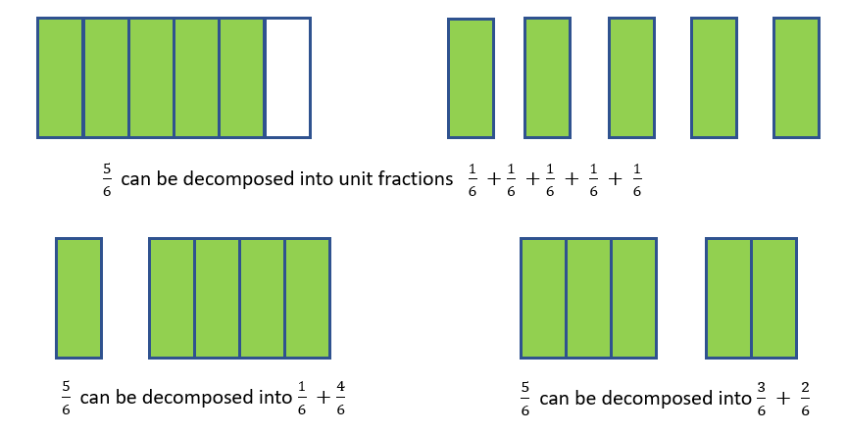

* Experiences at this level should include exploring and reasoning about comparing fractions in context (e.g., If a recipe requires one-half cup of sugar, and if there is one-third cup of sugar in the kitchen, will that be enough to make the recipe?)
* A variety of experiences focusing on comparing includes:
  + fractions with like denominators;
  + fractions with like numerators;
  + fractions that are more than one whole and less than one whole; and
  + fractions close to zero, close to one-half, and close to one whole.
* Comparing fractions with like denominators involves comparing only the numerators or the number of pieces.
* Comparing fractions with like numerators involves thinking about the size of the fractional parts. The more parts the whole is divided into, the smaller each part will be (e.g., < ).

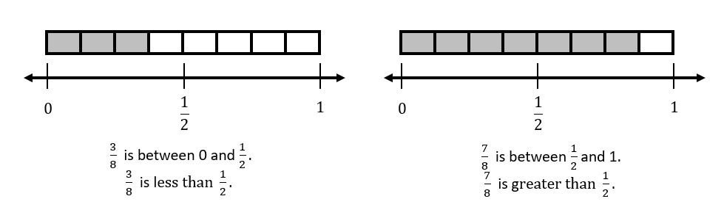

* Equivalent fractions name the same amount. Students should have multiple opportunities to explore and use a variety of representations including visual fraction models and folding paper to represent, explore, and explain why two fractions are equivalent. For example, is equivalent to because the fractions themselves represent the same value, even though the number and size of the parts differ.

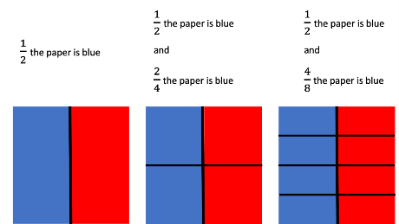

###### Skills in Practice

While the five process goals are expected to be embedded in each standard, the Skills in Practice highlight the most prevalent process goals in relation to the content presented.

**Mathematical Reasoning:** When comparing fractions, students will often try to apply whole number reasoning to fractions. For example, given the fractions and , students may say that is greater than because “3 is greater than 2.” Students who use the numbers in the denominators to compare are not comparing the size of the parts and may not understand that the larger the denominator, the smaller the parts. Similarly, students may only consider the numerator when comparing. Given the fractions and , students may say that is greater than because “4 is greater than 2.” Students who make these errors would benefit from additional experiences with manipulatives that students can use to directly compare different fractions of the same whole.

**Mathematical Representations:**

* When given a model, students may have difficulty writing the fraction. In the model below, instead of correctly identifying the shaded part of the circle as students may write the fraction as (the number of unshaded parts as the numerator and the number of shaded part as the denominator), (the number of unshaded parts as the numerator and the number of shaded parts as the denominator), or (the number of total parts as the numerator and the number of shaded parts as the denominator). Errors such as these indicate a lack of understanding that the denominator names the total number of equal parts in the whole. Activities that help students develop conceptual understanding of the numerator and denominator in a fraction and ask students to name the number of pieces described in the model. Practice naming examples and non-examples may also help students distinguish between correct and incorrect names for fractions.

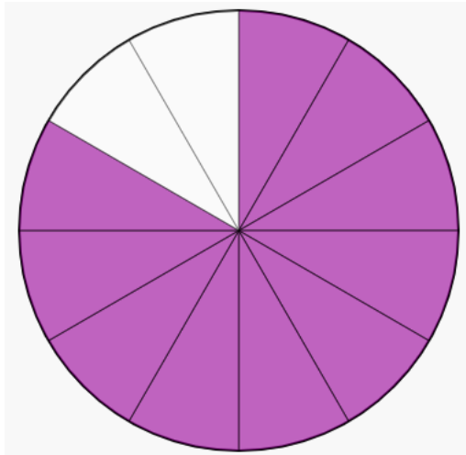

* Students may struggle with representing fractions and mixed numbers on a number line. In the example below, students may incorrectly identify the arrow as representing (if they did not understand that the 1 represents one whole), (if they count the tick marks instead of the spaces and did not understand that the 1 represents one whole), or (if they recognized the 1 represents one whole but then counted the tick marks instead of the spaces).

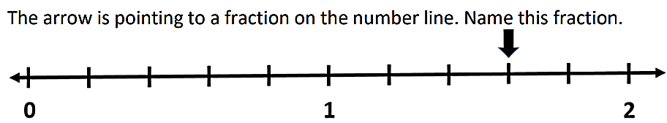

* Students can represent composition and decomposition of fractions with an expression or with various part-part-whole representations. See the examples below.

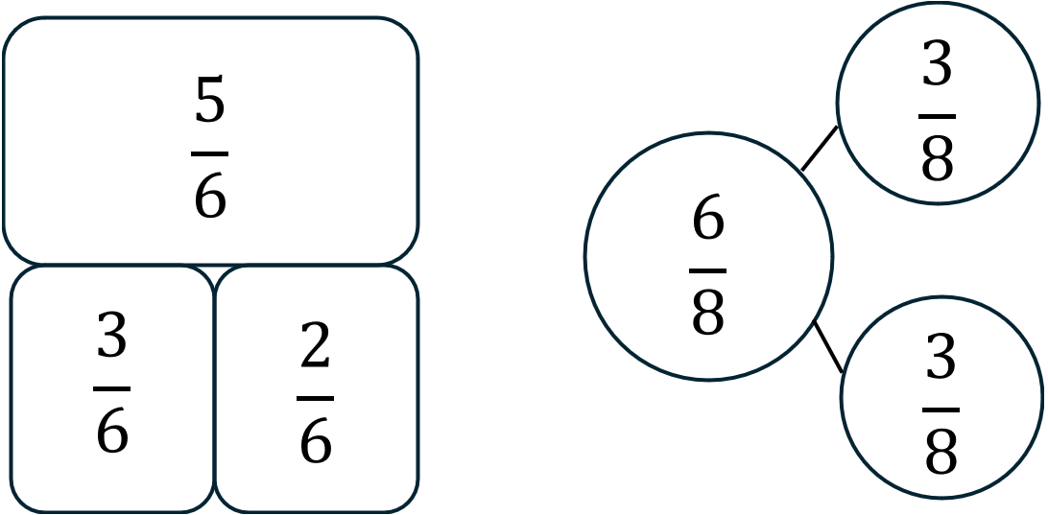 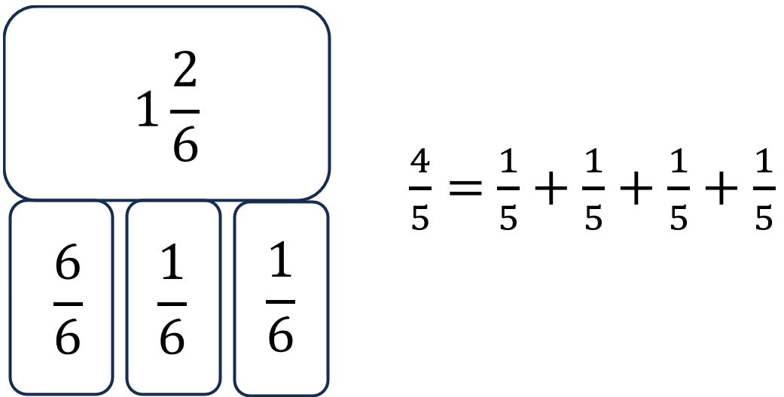

###### Concepts and Connections

Concepts

Flexibility with composing and decomposing base 10 numbers and understanding the structure to build relationships among numbers allows us to quantify, measure, and make decisions in life.

Connections

* *Within the grade level/course*:
  + 3.MG.1 – The student will reason mathematically using standard units (U.S. Customary and metric) with appropriate tools to estimate and measure objects by length, weight/mass, and liquid volume to the nearest half or whole unit.
* *Vertical Progression*:
  + 2.NS.3 – The student will use mathematical reasoning and justification to solve contextual problems that involve partitioning models into equal-sized parts (halves, fourths, eighths, thirds, and sixths).
  + 4.NS.3 - The student will use mathematical reasoning and justification to represent, compare, and order fractions (proper, improper, and mixed numbers with denominators 12 or less), with and without models.
  + 4.CE.3 – The student will estimate, represent, solve, and justify solutions to single-step problems, including those in context, using addition and subtraction of fractions (proper, improper, and mixed numbers with like denominators of 2, 3, 4, 5, 6, 8, 10, and 12), with and without models; and solve single-step contextual problems involving multiplication of a whole number (12 or less) and a unit fraction, with models.

Across Content Areas

Reference 3.NS.1.

###### Resources to Support Local Curriculum

* A list of approved textbooks and instructional materials is posted on the VDOE [website](https://www.doe.virginia.gov/teaching-learning-assessment/k-12-standards-instruction/mathematics/2024-mathematics-textbooks).
* Composing and Decomposing Fractions Exemplar Mathematics Instructional Plan ([Word](https://www.doe.virginia.gov/home/showpublisheddocument/51785/638398746005900000) | [PDF](https://www.doe.virginia.gov/home/showpublisheddocument/51787/638398746012000000))
* Composing and Decomposing Fractions Centers Exemplar Mathematics Instructional Plan ([Word](https://www.doe.virginia.gov/home/showpublisheddocument/51781/638398745993870000) | [PDF](https://www.doe.virginia.gov/home/showpublisheddocument/51783/638398745999630000))

### 3.NS.4

##### The student will solve problems, including those in context, that involve counting, comparing, representing, and making change for money amounts up to $5.00.

1. Students will demonstrate the following Knowledge and Skills:
2. Determine the value of a collection of bills and coins whose total is $5.00 or less.
3. Construct a set of bills and coins to total a given amount of money whose value is $5.00 or less.
4. Compare the values of two sets of coins or two sets of bills and coins, up to $5.00, with words (*greater than, less than, equal to)* and/or symbols (>, <, =) using concrete or pictorial models.
5. Solve contextual problems to make change from $5.00 or less by using counting on or counting back strategies with concrete or pictorial models.

###### Understanding the Standard

* Students benefit from engaging in everyday opportunities to count a collection of coins and one-dollar bills and compare two collections of coins and one-dollar bills whose total values are $5.00 or less.
* Representing the value of coins can be demonstrated using a variety of organizers such as 5- and 10-frames, hundreds charts, or proportional money pieces.
* The value of a collection of coins and bills can be determined by:
  + counting on;
  + beginning with the highest value; and/or
  + grouping the coins and bills into groups that are easier to count.
* Skip counting strategies are beneficial when determining the value of groups of like coins.
* One strategy that can be used to make change during a purchase includes counting on by using coins and then bills (e.g., starting with the amount to be paid, the purchase price, and counting on until the amount given is reached). See the following example.

Haley is helping her mom in the Little League concession stand. A customer’s bill is $2.68, and he gives Haley a five-dollar bill to pay for his purchase. How could Haley use counting on to give the correct amount of change to the customer?

* An efficient way to return change is to count on as you lay down each coin or bill. If the customer’s purchase cost is $2.68, the change could be counted out in the following ways:

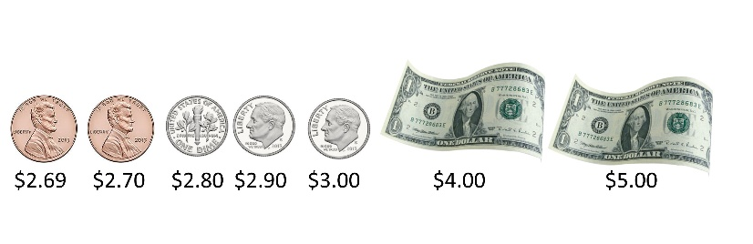

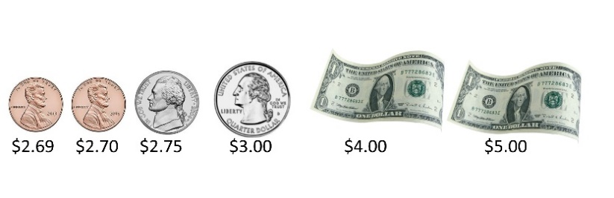

The customer should receive $2.32 as his change.

###### Skills in Practice

While the five process goals are expected to be embedded in each standard, the Skills in Practice highlight the most prevalent process goals in relation to the content presented.

**Mathematical Problem Solving:** Students may struggle to solve problems that require determining the amount of change to give. For example, given a problem such as, “Kevin purchased a hot dog for $2.72. He gave the cashier $5.00. How much change did Kevin receive?” Common errors that students may make when solving this problem include:

* Adding the price of the purchase to the amount paid ($2.72 + $5.00 = $7.72). This indicates that students did not understand the question being asked or did not understand how to solve a “making change” problem. These students would benefit from experiences in which they act out the context of the problem to develop conceptual understanding.
* Subtracting to find the amount of change and making a computation error (e.g., forgetting to change the 5 to a 4 when regrouping; regrouping one of the dollars as 10 dimes and 10 pennies; or regrouping one of the dollars as 10 dimes and 9 pennies). Because students have not been formally introduced to decimals, teachers should encourage students to use other strategies when determining the amount of change. For example, the strategy of “counting on” from the purchase cost, using coins and bills is helpful. See the example above in “Understanding the Standard.”

**Mathematical Reasoning:** When comparing the values of two sets of bills and coins, students may reason incorrectly to determine which set has a greater value. Given two equivalent sets below, Set T and Set X, students may say that Set X has a greater value because it has three one-dollar bills and Set T only has two one-dollar bills. Students may also say that Set X is greater because there are 12 coins and Set T only has ten coins. These errors indicate that students are not considering the value of the entire set but are relying on the value of the dollar bills or on the number of coins in each set. Students would benefit from additional practice determining the value of a set of coins and bills and hearing peers’ strategies for comparing sets of money in which the coins have not been organized by value.

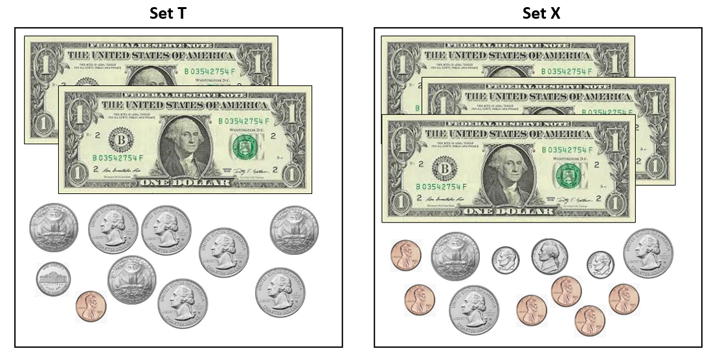

**Mathematical Representations:** Students may have difficulty counting a set of bills and coins, especially when amounts cross over a dollar and/or when the set is not presented in an organized and ordered way, as seen in the example below. Opportunities to practice strategies for counting sets of bills and coins using manipulatives and then transitioning to pictorial representations, may be helpful. Additional experiences to practice skip counting by values of coins using a hundred chart or number line may also be beneficial.

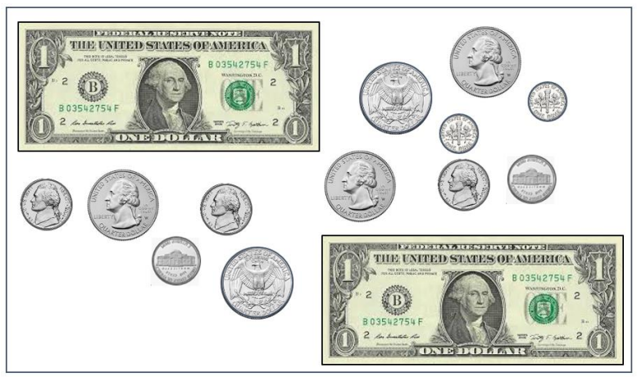

###### Concepts and Connections

Concepts

Flexibility with composing and decomposing base 10 numbers and understanding the structure to build relationships among numbers allows us to quantify, measure, and make decisions in life.

Connections

* *Within the grade level/course*:
  + 3.CE.1 – The student will estimate, represent, solve, and justify solutions to single-step and multistep problems, including those in context, using addition and subtraction with whole numbers where addends and minuends do not exceed 1,000.
* *Vertical Progression*:
  + 2.NS.4 – The student will solve problems that involve counting and representing money amounts up to $2.00.
  + 4.CE.4 – The student will estimate, represent, solve, and justify solutions to single-step and multistep problems, including those in context, using addition and subtraction of decimals through the thousandths, with and without models.

Across Content Areas

Reference 3.NS.1.

###### Resources to Support Local Curriculum

* A list of approved textbooks and instructional materials is posted on the VDOE [website](https://www.doe.virginia.gov/teaching-learning-assessment/k-12-standards-instruction/mathematics/2024-mathematics-textbooks).

## Computation and Estimation

In K-12 mathematics, computation and estimation are integral to developing mathematical proficiency. Computation refers to the process of performing numerical operations, such as addition, subtraction, multiplication, and division. It involves applying strategies and algorithms to solve arithmetic problems accurately and efficiently. Estimation is the process of obtaining a reasonable or close approximation of a result without performing an exact calculation. Estimation is particularly useful when an exact answer is not required, especially in real-world situations, and when assessing the reasonableness of an answer. Computation and estimation are used to support problem solving, critical thinking, and mathematical reasoning by providing students with a range of approaches to solve mathematics problems quickly and accurately.

In Grade 3, students understand that the operations of addition, subtraction, multiplication, and division are used to represent and solve many different types of problems. At this grade level, students will represent, solve, and justify solutions to single-step and multistep problems, including those in context, using addition and subtraction with whole numbers (addends and minuends do not exceed 1,000); represent, solve, and justify solutions to single-step problems using multiplication and division; and recall with automaticity multiplication facts through 10 × 10 and the corresponding division facts. For building automaticity, the intentional use of timed exercises, such as flashcards and/or supplemental handouts aligned to the rigor of the standard that require students to generate many correct responses in a short amount of time are highly encouraged.

It is critical at this grade level that while students build their conceptual understanding through concrete and pictorial representations, that students also apply standard algorithms when performing operations as specified within the parameters of each standard of this strand. At this grade level, students become more efficient with problem solving strategies. Fluent use of standard algorithms not only depends on automatic retrieval (automaticity) but also reinforces them. Practice provides the foundation allowing students the ability to achieve mathematically accurate and systematic use of basic skills at a reasonably quick pace – freeing up working memory to solve complex problems in later grades. Automaticity further grounds students’ entry points and the structures needed to solve contextual problems and execute mathematical procedures.

### 3.CE.1

##### The student will estimate, represent, solve, and justify solutions to single-step and multistep problems, including those in context, using addition and subtraction with whole numbers where addends and minuends do not exceed 1,000.

1. Students will demonstrate the following Knowledge and Skills:
2. Determine and justify whether an estimate or an exact answer is appropriate when solving single-step and multistep contextual problems involving addition and subtraction, where addends and minuends do not exceed 1,000.
3. Apply strategies (e.g., rounding to the nearest 10 or 100, using compatible numbers, using other number relationships) to estimate a solution for single-step or multistep addition or subtraction problems, including those in context, where addends or minuends do not exceed 1,000.
4. Apply strategies (e.g., place value, properties of addition, other number relationships) and algorithms, including the standard algorithm, to determine the sum or difference of two whole numbers where addends and minuends do not exceed 1,000.
5. Identify and use the appropriate symbol to distinguish between expressions that are equal and expressions that are not equal (e.g., 256 - 13 = 220 + 23; 457 + 100 ≠ 557 + 100).
6. Represent, solve, and justify solutions to single-step and multistep contextual problems involving addition and subtraction with whole numbers where addends and minuends do not exceed 1,000.

###### Understanding the Standard

* Estimation skills are valuable, time-saving tools particularly in practical situations when exact answers are not required. Estimates can also be used in determining the reasonableness of the sum or difference when solving for the exact answer.
* An estimate is a number that lies within a range of the exact solution, and the estimation strategy used in a particular problem determines how close the estimate is to the exact solution.
* Estimates involve using friendlier numbers to mentally compute a reasonable answer before any exact computation is calculated.
* Reasons for estimation can be explored using practical experiences and various estimation strategies to solve contextual problems. When estimating, students should consider whether it is important that the estimate is greater than or less than the exact answer. This may inform the choice of estimation strategy. In the following examples using the same addends, each estimation strategy results in a different sum, so students should be encouraged to examine the context and the demand for precision when deciding which estimation strategy to use. Estimation strategies include rounding, using compatible numbers, and front-end estimation:
* Rounding numbers is one estimation strategy and may be introduced using a number line. When given a number to round, use multiples of ten, hundred, or thousand as benchmarks and use the nearest benchmark value to represent the number. For example, using rounding to the nearest hundred to estimate the sum of 255 + 481 would result in 300 + 500 = 800.
* Using compatible numbers is another estimation strategy. Compatible numbers are two or more numbers that are easy to add and subtract mentally. For example, using compatible numbers to estimate the sum of 255 + 481 could result in 250 + 450 = 700.
* Using front-end estimation is another estimation strategy. Front-end estimation involves truncating numbers to the highest place value to compute. For example, using front-end estimation to estimate the sum of 255 + 481 would result in 200 + 400 = 600. Front-end estimation may be more useful when working with larger numbers. While it is an efficient strategy, it may not result in an estimate that is as close to the exact answer as other estimation strategies.
* Students would benefit from hearing the estimation strategies of other classmates and from discussions about how different estimation strategies produce different answers (e.g., rounding numbers may produce an estimate closer to the actual answer than using front-end estimation).
* Conceptual understanding and computational fluency are built by using various strategies and representations. Regrouping is used in addition and subtraction algorithms and can be challenging for many students to understand. Using concrete materials (e.g., base 10 blocks, connecting cubes, beans and cups, etc.) to explore, model, and stimulate discussion about a variety of problem situations helps students understand the concept of regrouping, and enables them to move from the concrete to the representational to the abstract (symbolic). Student-created representations, such as drawings, diagrams, tally marks, graphs, or written comments are strategies that help students make these connections that lead to developing computational fluency.
* ​​​Addition is the combining of quantities. Addition problems use the following terms:
  + *addend* →     423
  + *addend* → + 246
  + *sum* →    669
* Subtraction is the inverse of addition. Subtraction yields the difference between two numbers. Subtraction problems use the following terms:
  + *minuend*   →        798
  + *subtrahend* →  – 541
  + *difference* →   257
* Flexible methods of adding whole numbers by combining numbers in a variety of ways, mostly depending on place values, are useful. Grade 3 students continue to explore and apply the properties of addition as strategies for solving addition and subtraction problems using a variety of representations (e.g., manipulatives, diagrams, symbols).

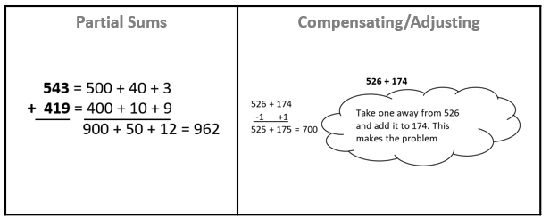

* Place value strategies include:
  + Using base 10 blocks to model the operation;
  + Decomposing both numbers into expanded form and operating on individual place values (e.g., partial sums, partial differences);
  + Decomposing one number to count on or count back, with or without a number line;
  + Using the standard algorithm    ​
* The properties of the operations are “rules” about how numbers work and how they relate to one another. Students at this level do not need to use the formal terms for these properties but should utilize these properties to further develop flexibility and fluency in solving problems. The following properties of addition are most appropriate for exploration at this level:
  + the commutative property of addition, which states that changing the order of the addends does not affect the sum (e.g., 4 + 3 = 3 + 4); and
  + the associative property of addition, which states that the sum stays the same when the grouping of addends is changed (e.g., 15 + (35 + 16) = (15 + 35) + 16)
* Equivalent relationship strategies include:
  + decomposing values to reach compatible numbers; and
  + compensation strategies (e.g., subtracting the same value from both numbers in a subtraction problem or adding a value to one addend and subtracting the same value from the other addend in an addition problem)
* In problem solving, emphasis is placed on thinking and reasoning rather than on key words. Focusing on key words such as *in all, altogether, difference,* etc.encourages students to perform a particular operation rather than make sense of the context of the problem. A focus on key words prepares students to solve a limited set of problems and often leads to incorrect solutions as well as challenges or misconceptions in subsequent grades and courses.
* Reasoning about problem solving can be developed using comprehension strategies such as visualizing, retelling, or acting out problem situations.
* Students should experience a variety of problem types related to addition and subtraction. Examples are included in the following chart:

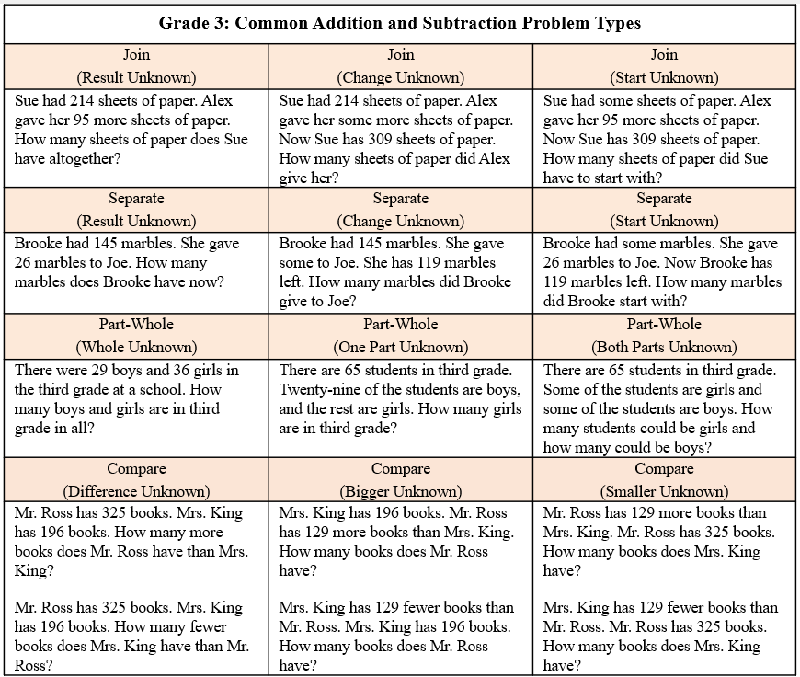

* Bar diagrams serve as a model that can provide students with a way to visualize, represent, and understand the relationship between known and unknown quantities and to solve problems. Examples are included in the following chart:

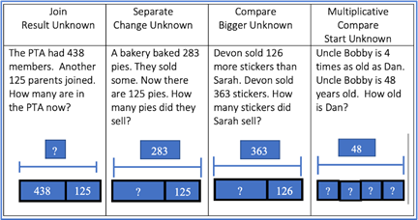

* Mathematical relationships can be expressed using equations (number sentences). A number sentence is an equation with numbers (e.g., 6 + 3 = 9; or 6 + 3 = 4 + 5).
* The equal symbol (=) means that the values on either side are equivalent (balanced). An equation can be represented using balance scales, with equal amounts on each side (e.g., 3 + 5 = 6 + 2).
* The not equal (≠) symbol means that the values on either side are not equivalent (not balanced).

###### Skills in Practice

While the five process goals are expected to be embedded in each standard, the Skills in Practice highlight the most prevalent process goals in relation to the content presented.

**Mathematical Problem Solving:**

Problem solving requires both an ability to correctly define a problem and find a solution to it. Model effective practices that demonstrate for students how to arrive at their solutions through estimation, exactness, and justification. To unpack contextual problems, guide students through the problem-solving process by taking care to annotate essential vocabulary (not “key words”) related to applied operations. For example –

* + Understand the problem by reading and then re-reading the problem; imagining the problem or drawing a picture; underlining or highlighting the important information and essential vocabulary within the problem.
  + Create a plan by deciding what to do and how to solve the problem using the applicable operation(s).
  + Carry out the plan by showing all work to represent thinking (e.g., using symbols, words, concrete manipulatives, pictorial representations).
  + Check the solution by determining if the solution answers the question asked in the contextual problem. During this phase of problem solving, it is essential that students are exposed to strategies that allow them to determine the reasonableness of their responses and solutions; and to support multiple mathematically sound and accurate ways of arriving at a solution.
  + Graphic organizers such as the four-square model (Polya method) can help students to organize their thinking as they solve contextual problems –

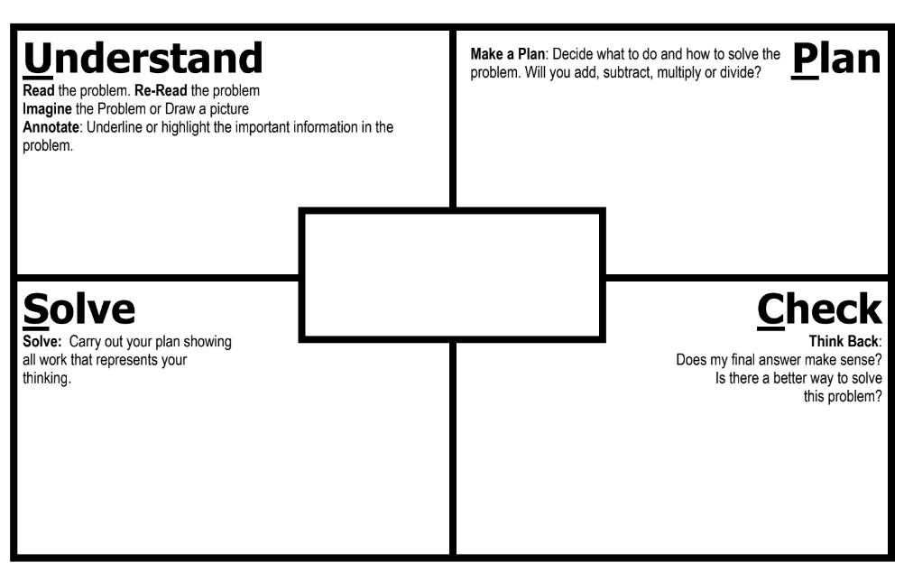

* As students solve contextual problems, ask questions such as –
  + Are there multiple ways to solve a single problem?
  + How do you know that you have provided a reasonable answer?
  + What role does estimation play in solving contextual problems?

As students engage in solving problems, including those in context, they should solve a variety of single-step and multistep problems using addition and subtraction. At this level, there are several common errors that students make when adding and subtracting larger numbers. Some examples of common errors are included in the chart below.

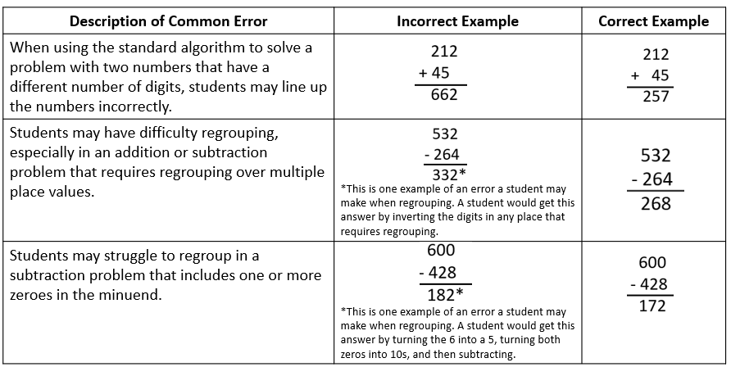

* Students who demonstrate consistent computation errors would benefit from experience using concrete manipulatives to build conceptual understanding. In addition, opportunities to hear a variety of computation strategies shared by peers may also expose students to alternate, efficient strategies that are less reliant on regrouping.

**Mathematical Reasoning:** Solving problems in contextual situations enhances proficiency with estimation strategies. Reasoning skills are essential for solving problems effectively and strategically. Reasoning involves analyzing information, identifying assumptions, evaluating evidence, and drawing logical conclusions. When solving problems in context, students may have difficulty understanding which operation(s) to use and may use the wrong operation(s) when solving. Students may not realize that all numbers in a contextual problem are not always needed. To help students derive meaning and determine which operation(s) to apply, ask students how thinking about the meaning of addition or subtraction can help when solving word problems. Give students a chance to explain individually and share their thoughts with each other. Have students explain the action of the word to move away from a reliance on “key words.” For example –

* Addition:
  + Finding the total quantity of separate quantities
  + Combining two or more quantities
* Subtraction:
  + Finding how much more or how much less
  + Finding how much further
  + Finding the difference between two quantities
  + Determining a quantity when taking one amount from another

**Mathematical Connections:** Students must connect fluency of facts, concepts, procedures, and mathematical language through mathematical reasoning to effectively solve contextual problems. Fluency with whole numbers at this grade level will help with improving logical reasoning skills, which will then support solving contextual problems. In the following example, first, students must use their previous understanding of computation with whole numbers. Next, students must apply their understanding of mathematical language to determine which operation(s) to use, and with this information, design a plan to solve the solution. Lastly, students must determine the reasonableness of their solution by providing their reasoning. An example, with common errors, is given below.

The town of Brookfield held a race to earn money for the school. There were 400 people signed up for the race. On the day of the race, 37 people dropped out of the race. There were also an additional 15 people that joined the race. How many total people ran the race?

A common error students may make is adding all three numbers together. This indicates that students have difficulty determining which operation to use and would benefit from additional practice visualizing and representing the action that is happening in a contextual situation. Another common mistake is for students to recognize that they need to subtract 400 – 37 but do so incorrectly. The use of concrete manipulatives when solving problems that require regrouping may be helpful. A third common mistake is for students to complete the first step of the problem (400 – 37) and stop, without completing the second step of the problem (363 + 15).

###### Concepts and Connections

Concepts

The operations of addition, subtraction, multiplication, and division are used to represent and solve many different types of problems.

Connections

* *Within the grade level/course*:
  + 3.PS.1 – The student will apply the data cycle (formulate questions; collect or acquire data; organize and represent data; and analyze data and communicate results) with a focus on pictographs and bar graphs.
  + 3.PFA.1 – The student will identify, describe, extend, and create increasing and decreasing patterns (limited to addition and subtraction of whole numbers), including those in context, using various representations.
* *Vertical Progression*:
  + 2.CE.1 – The student will recall with automaticity addition and subtraction facts within 20 and estimate, represent, solve, and justify solutions to single-step and multistep problems, including those in context, using addition and subtraction with whole numbers where addends or minuends do not exceed 100.
  + 4.CE.1 – The student will estimate, represent, solve, and justify solutions to single-step and multistep problems, including those in context, using addition and subtraction with whole numbers.

###### Resources to Support Local Curriculum

* A list of approved textbooks and instructional materials is posted on the VDOE [website](https://www.doe.virginia.gov/teaching-learning-assessment/k-12-standards-instruction/mathematics/2024-mathematics-textbooks).

### 3.CE.2

##### The student will recall with automaticity multiplication and division facts through 10 × 10; and represent, solve, and justify solutions to single-step contextual problems using multiplication and division with whole numbers.

1. Students will demonstrate the following Knowledge and Skills:
2. Represent multiplication and division of whole numbers through 10 × 10, including in a contextual situation, using a variety of approaches and models (e.g., repeated addition/subtraction, equal-sized groups/sharing, arrays, equal jumps on a number line, using multiples to skip count).
3. Use inverse relationships to write the related facts connected to a given model for multiplication and division of whole numbers through 10 × 10.
4. Apply strategies (e.g., place value, the properties of multiplication and/or addition) when multiplying and dividing whole numbers.
5. Demonstrate fluency with multiplication facts through 10 × 10 by applying reasoning strategies (e.g., doubling, add-a-group, subtract-a-group, near squares, and inverse relationships).
6. Represent, solve, and justify solutions to single-step contextual problems that involve multiplication and division of whole numbers through 10 × 10.
7. Recall with automaticity the multiplication facts through 10 × 10 and the corresponding division facts.
8. Create an equation to represent the mathematical relationship between equivalent expressions using multiplication and/or division facts through 10 × 10 (e.g., 4 × 3 = 14 - 2, 35 ÷ 5 = 1 × 7).

###### Understanding the Standard

* In Grade 2, students had experience exploring skip counting patterns for 2s, 5s, and 10s, and building equal groups to represent those patterns. This content provides background knowledge to support initial understandings of multiplication.
* The terms associated with multiplication are listed below:

image showing 4 times 3 equals 12, with the 4 and 3 labeled as factors, and the 12 labeled as product

* The formats and terms associated with division are listed below:

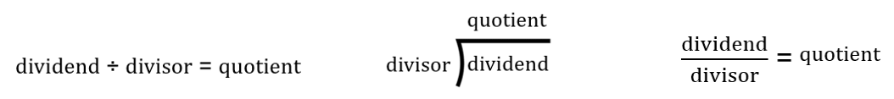

* Multiplication and division are inverse operations.
* Students develop an understanding of the meaning of multiplication and division of whole numbers through activities and contextual problems that involve equal-sets or equal-groups, arrays, and length models.
* The equal-sets or equal-groups model lends itself to sorting a variety of concrete objects into equal groups. It reinforces the concept of multiplication as a way to find the total number of items in a collection of groups, with the same amount in each group, using repeated addition or skip counting. The equal groups model represents division as fair shares by defining the number of groups and sharing items one by one until all items are equally distributed or by determining the number of equal groups of a given size required to exhaust all the items. The image below shows three groups of four circles, which can be represented as 4 + 4 + 4 = 12 or as 3 × 4 = 12. It could also be represented as 12 – 4 – 4 – 4 = 0 or as 12 ÷ 3 = 4 or as 12 ÷ 4 = 3.

Three groups of four circles

* The array model consists of rows and columns (e.g., three rows of four columns for a 3-by-4 array). In a multiplication problem, the numbers of rows and columns represent the two factors, and the total number of squares represents the product. In a division problem, the total number of squares represents the dividend, and the number of the rows and columns represent the divisor and quotient.

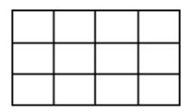

* The length model (e.g., a number line) reinforces the relationship between repeated addition (skip counting) and multiplication. For example, the model below shows 3 jumps of 4 or skip counting 4, 8, 12 to solve 3 × 4.

Number line from 0 to 20 with three jumps from 0 to 4, 4 to 8, and 8 to 12.

* The number line model can also be used to solve a division problem, such as 6 ÷ 3 represented on the number line below by noting how many jumps of three are needed to go from six to zero (i.e., 6 ÷ 3 = 2).

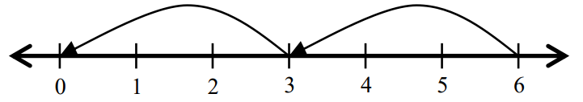

* Dividing by zero is undefined because it always leads to a contradiction. As demonstrated below, there is no single defined number possibility for *r* when dividing by 0, since zero multiplied by any number is zero: If 12 ÷ 0 = *r*, then *r* × 0 = 12.
* Computational fluency is the ability to think flexibly in order to choose appropriate strategies to solve problems accurately and efficiently. Students should develop fluency and recall with automaticity multiplication and division facts through 10 × 10.
* Flexibility requires knowledge of more than one approach to solving a particular kind of problem. Being flexible allows students to choose an appropriate strategy for the numbers involved, particularly where they do not need to recall with automaticity.
* Meaningful practice of computation strategies can be attained through hands-on activities, manipulatives, and graphic organizers.
* Accuracy is the ability to determine a correct answer using knowledge of number facts and other important number relationships.
* Efficiency is the ability to carry out a strategy effortlessly at a reasonably quick pace.
* The development of computational fluency relies on quick access to number facts. The patterns and relationships that exist in the facts can be used to learn and retain the facts. By studying patterns and relationships, students build a foundation for fluency with multiplication and division facts.
* Automaticity of facts can be achieved through timed exercises such as flashcards and/or supplemental handouts to generate many correct responses in a short amount of time. By the end of Grade 3, students are expected to be able to recall with automaticity all multiplication and division facts through 10 × 10.
* Beginning with learning the foundational multiplication facts for 0, 1, 2, 5, and 10 allows students to utilize prior skip counting skills and the use of doubles to solve problems. Understanding and using the foundational facts can be helpful in ​​deriving and learning all multiplication facts. For example, decomposing one of the factors in 7 × 6 allows for the use of the foundational facts of 5s and 2s. This knowledge can be combined to learn the facts for 7 (e.g., 7 × 6 can be thought of as (5 × 6) + (2 × 6)).
* The properties of the operations are “rules” about how numbers work and how they relate to one another. Students at this level do not need to use the formal terms for these properties but should utilize these properties to further develop flexibility and fluency in solving problems. The following properties are most appropriate for exploration at this level:
  + The commutative property of multiplication states that changing the order of the factors does not affect the product (e.g., 2 × 3 = 3 × 2).
  + The identity property of multiplication states that multiplying a number by one results in a product that is the same as the given number (e.g., 7 × 1 = 7).
  + The associative property of multiplication states that the product stays the same when the grouping of factors is changed (e.g., 6 × (3 × 5) = (6 × 3) × 5).
  + The distributive property states that multiplying a sum by a number gives the same result as multiplying each addend by the number and then adding the products:

8 × 7 = 8 × (5 + 2)

8 × 7 = (8 × 5) + (8 × 2)

8 × 7 = 40 + 16

8 × 7 = 56

* Strategies that allow students to derive unknown multiplication facts include:
  + doubles (2s facts; double 9 is 18 so 9 × 2 = 18);
  + doubling twice (4s facts; double 6 is 12 and double 12 is 24 so 6 × 4 = 24);
  + doubling three times (8s facts; double 7 is 14 and double 14 is 28 and double 28 is 56 so 7 × 8 = 56);
  + halving (5s facts are half of ten; half of 80 is 40 so 8 × 5 = 40);
  + decomposing into known facts using the distributive property (e.g., 7 × 3 can be thought of as (5 × 3) + (2 × 3));
  + building up and building down from known facts (9 × 3 can be thought of as (10 × 3) – (1 × 3)).
  + the inverse relationship between division and multiplication (5 × 3 = 15 so 15 ÷ 3 = 5);
  + halving (2s facts; half of 16 is 8 so 16 ÷ 2 = 8);
  + halving twice (4s facts; half of 28 is 14 and half of 14 is 7 so 28 ÷ 4 = 7); and
  + halving three times (8s facts; half of 48 is 24, half of 24 is 12, and half of 12 is 6 so 48 ÷ 8 = 6).
* Examples of multiplication and division strategies are shown in the table below.

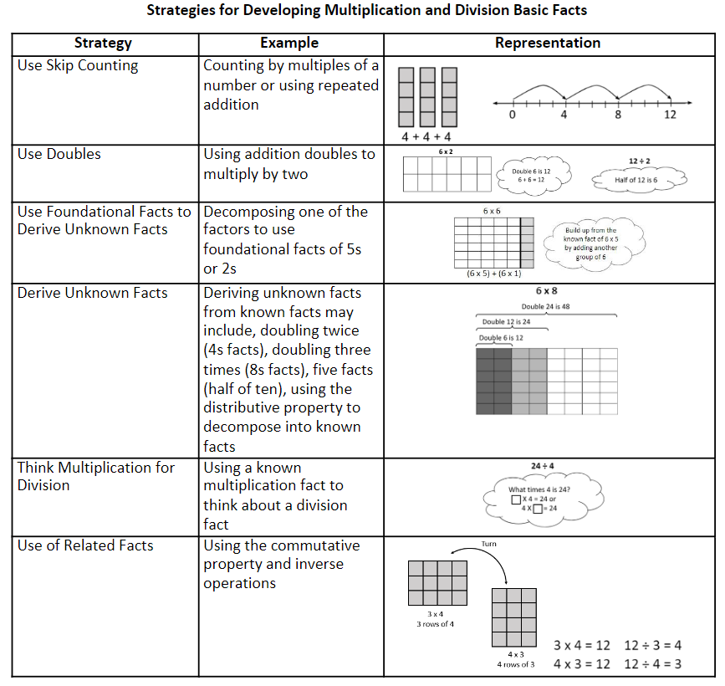

* Students should experience a variety of problem types related to multiplication and division. Some examples are included in the following chart:

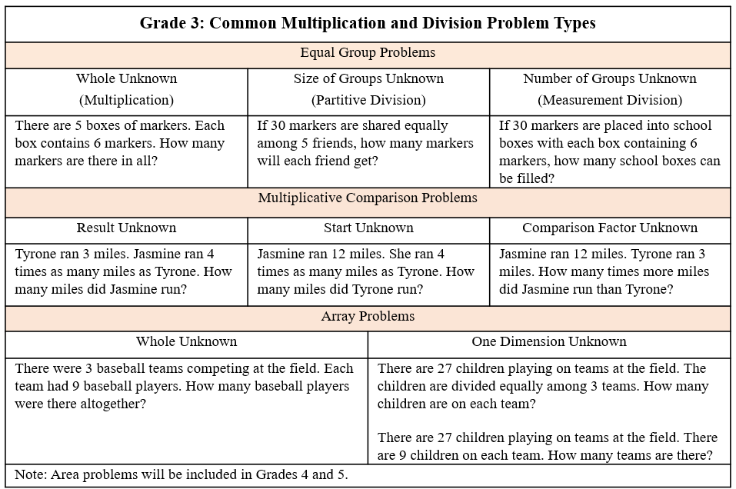

* An equation is a mathematical sentence in which two expressions are equivalent. It consists of two expressions, one on each side of an equal symbol (e.g., 6 × 3 = 18, 10 = 5 × 2, 4 × 3 = 2 × 6). An equation can be represented using balance scales, with equal amounts on each side (e.g., 4 × 1 = 2 + 2).

###### Skills in Practice

While the five process goals are expected to be embedded in each standard, the Skills in Practice highlight the most prevalent process goals in relation to the content presented.

**Mathematical Problem Solving**:

* Problem solving requires both an ability to correctly define a problem and find a solution to it. Model effective practices that demonstrate for students how to arrive at their solutions through estimation, exactness, and justification. To unpack contextual problems, guide students through the problem-solving process by taking care to annotate *essential vocabulary* (not “key words”) related to applied operations. For example –
  + Understand the problem by reading and then re-reading the problem; imagining the problem or drawing a picture; underlining or highlighting the important information and essential vocabulary within the problem.
  + Create a plan by deciding what to do and how to solve the problem using the applicable operation(s).
  + Carry out the plan by showing all work to represent thinking (e.g., using symbols, words, concrete manipulatives, pictorial representations).
  + Check the solution by determining if the solution answers the question asked in the contextual problem. During this phase of problem solving, it is essential that students are exposed to strategies that allow them to determine the reasonableness of their responses and solutions; and to support multiple mathematically sound and accurate ways of arriving at a solution.
  + Graphic organizers such as the four-square model (Polya method) can help students to organize their thinking as they solve contextual problems –



* As students solve contextual problems, ask questions such as –
  + Are there multiple ways to solve a single problem?
  + How do you know that you have provided a reasonable answer?
  + What role does estimation play in solving contextual problems?
* Automatic retrieval of facts (automaticity) allows students more mental energy to devote to relatively complex mathematical tasks and execute multistep mathematical procedures. Thus, building automatic fact retrieval in students is one (of many) important goal when engaging in problem solving.
  + Ensure that students have an efficient strategy to use as they solve basic facts. When teaching basic facts, instruction should be organized related to number patterns (see list of strategies in Understanding the Standard section). For example, when solving single-step multiplication facts within 10 × 10, students should use flexible counting strategies and/or models (e.g., arrays, number lines) to develop their automaticity while also developing their conceptual understanding of multiplication and division. Students should demonstrate their understanding using words, objects, drawings, and numbers. For example, when given 3 × 4 = ___, students can create a concrete model or pictorial representation. A number line (see below) is one strategy that can be used to support students’ learning of math facts to build both automaticity and procedural fluency.

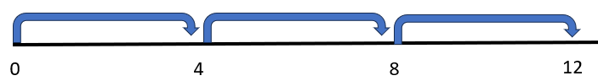

* + Timed activities should be added once students have been working on developing accuracy and flexibility with such facts over many lessons. Choose the activity and materials to use in the timed activity while setting clear expectations. Timed activities can be structured for students to work together as a group or individually. If using worksheets for fluency, discuss students’ answers after time has been called and ask students to correct and explain any missed items. For group timed activities, students work in pairs or small groups, taking turns to respond or responding at once. For group activities or flash cards with a teacher, teachers should provide immediate feedback. If students are incorrect, teachers should allow students to self-correct and help them do so if necessary. Having students chart their individual progress over time can build motivation to set goals and encourage students to stay focused on achieving fluency and automaticity.
* Students may have difficulty solving contextual problems that involve multiplication and division. Consider a contextual problem such as, “Jason has 9 packages of muffins. Each package has 3 muffins. What is the total number of muffins in these packages?” Students may see the word *total* and choose to add 9 + 3 instead of multiply 9 × 3. Other students may think they need to divide 9 ÷ 3. Students who make these errors are not using the context of the problem to determine the operation needed to solve the problem. They would benefit from visualizing the problem and creating a model to represent the situation prior to solving it. Providing opportunities for students to share different representations of models and the associated number sentences that represent their thinking may help students develop problem-solving strategies as they make meaning for multiplication and division.

**Mathematical Communication:** Teach students a solution method for solving each problem type. Introduce a solution method using a worked-out example. Talk through the problem-solving process and connect the relevant problem information to the worked-out example. Say out loud the decisions that were made to solve the problem at each step. Then demonstrate how to apply the solution method by solving a similar problem with students using that method. Discuss each decision made and ask students guiding questions to engage them as problems are solved.

**Mathematical Reasoning:**

* Solving problems in contextual situations enhances proficiency with estimation strategies. Reasoning skills are essential for solving problems effectively and strategically. Reasoning involves analyzing information, identifying assumptions, evaluating evidence, and drawing logical conclusions. Students should apply a variety of reasoning strategies as they build the accuracy and flexibility components of fluency with multiplication and division up to 10 × 10 (e.g., skip counting, number lines, arrays). When solving problems in context, students may have difficulty understanding which operation(s) to use and may use the wrong operation(s) when solving. Students may not realize that all numbers in a contextual problem are not always needed. To help students derive meaning and determine which operation(s) to apply, ask students how thinking about the meaning of multiplication and division can help when solving word problems. Have students explain individually and share their thoughts with each other. Have students explain the action of the word to move away from a reliance on “key words.” For example –
  + Multiplication:
    - Finding the quantity needed for *x* number of people or *x* number of something
    - Having equal groups and finding the total of all groups
  + Division:
    - Dividing an item (or quantity) into equal sized pieces
    - Dividing a quantity into equal groups
    - Using an equal amount of something over time
* Basic fact strategies use number relationships and benchmarks and support students, merging conceptual understanding and procedural fluency. Strategies such as “five facts plus an extra group” to determine the × 6 facts will help students build a foundation for strategies beyond basic facts. For example –

**7** × **6 = _____**

When looking at this problem, students need to determine the total of 7 groups of 6 objects. Square tiles may be used to create an array that contains 7 rows, with 6 square tiles in each row. Students would then determine how many square tiles are in the array to determine the product of 7 × 6. For example, students may recognize that 7 × 5 = 35, and that they then need to add one more group of 7, for a total of 42. To transfer from the concrete, students would draw an array with 7 rows, with each row to include 6 squares. The product (42) is how many squares are drawn in all.

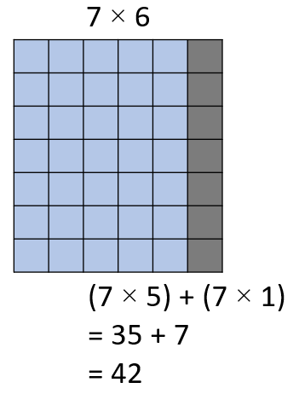

**Mathematical Connections:** When writing a set of related facts, students commonly struggle with writing the division facts accurately. For example, given the fact 7 × 5 = 35, students may incorrectly write 7 ÷ 5 = 35 as a related division fact. Students are often more comfortable with multiplication than division. With practice composing, decomposing, modeling, looking at relationships among fact families, and having students provide verbal explanations, students can better understand how multiplication and division are related, helping to develop their accuracy and flexibility components of computational fluency.

**Mathematical Representations:** As students begin their formal study of multiplication and division in Grade 3, they should be encouraged to represent problems in multiple ways, including the use of concrete manipulatives (e.g., counters), equal groups, number lines, and arrays/area models. Students may struggle to represent a multiplication or division problem in multiple ways and will benefit from experiences that include not only solving and representing problems involving equal groups where the whole is unknown or the size of the group is unknown, but also problems involving multiplicative comparisons. Students should be exposed to the various problem types listed in the “Understanding the Standard” section above as they apply the standard algorithms for multiplication and division.

###### Concepts and Connections

Concepts

The operations of addition, subtraction, multiplication, and division are used to represent and solve many different types of problems.

Connections

* *Within the grade level/course*:
  + 3.CE.1 – The student will estimate, represent, solve, and justify solutions to single-step and multistep problems, including those in context, using addition and subtraction with whole numbers where addends and minuends do not exceed 1,000.
* *Vertical Progression*:
  + 2.NS.1c – Describe and use patterns in skip counting by multiples of 2 (to at least 50), and multiples of 5, 10, and 25 (to at least 200) to justify the next number in the counting sequence.
  + 4.CE.2 – The student will estimate, represent, solve, and justify solutions to single-step and multistep problems, including those in context, using multiplication with whole numbers, and single-step problems, including those in context, using division with whole numbers; and recall with automaticity the multiplication facts through 12 × 12 and the corresponding division facts.

###### Resources to Support Local Curriculum

* A list of approved textbooks and instructional materials is posted on the VDOE [website](https://www.doe.virginia.gov/teaching-learning-assessment/k-12-standards-instruction/mathematics/2024-mathematics-textbooks).

## Measurement and Geometry

In K-12 mathematics, measurement and geometry allow students to gain understanding of the attributes of shapes as well as develop an understanding of standard units of measurement. Measurement and geometry are imperative as students develop a spatial understanding of the world around them. The standards in the measurement and geometry strand aim to develop students’ special reasoning, visualization, and ability to apply geometric and measurement concepts in real-world situations.

In Grade 3, students analyze and describe geometric objects, the relationships and structures among them, and the space they occupy to classify, quantify, measure, or count one or more attributes. At this grade level, students will estimate and measure objects by length, weight, and liquid volume to the nearest half or whole unit (U.S. Customary and metric); solve problems involving area and perimeter (in U.S. Customary and metric units); demonstrate an understanding of the concept of time to the nearest minute and solve elapsed time problem in one-hour increments; identify, describe, classify, and compare polygons; and combine and subdivide triangles and quadrilaterals to create new polygons.

### 3.MG.1

##### The student will reason mathematically using standard units (U.S. Customary and metric) with appropriate tools to estimate and measure objects by length, weight/mass, and liquid volume to the nearest half or whole unit.

1. Students will demonstrate the following Knowledge and Skills:
2. Justify whether an estimate or an exact measurement is needed for a contextual situation and choose an appropriate unit.
3. Estimate and measure:
   1. length of an object to the nearest U.S. Customary unit ( inch, inch, foot, yard) and metric unit (centimeter, meter);
   2. weight/mass of an object to the nearest U.S. Customary unit (pound) and metric unit (kilogram); and
   3. liquid volume to the nearest U.S. Customary unit (cup, pint, quart, gallon) and metric unit (liter).
4. Compare estimates of length, weight/mass, or liquid volume with the actual measurements.

###### Understanding the Standard

* The concept of a standard measurement unit is one of the major ideas in understanding measurement. Familiarity with standard units is developed through hands-on experiences of comparing, estimating, and measuring.
* Students benefit from opportunities to evaluate their estimates for reasonableness and refine their estimates to increase the accuracy of future measurements.
* One unit of measure may be more appropriate than another to use when measuring an object, depending on the size of the object and the degree of accuracy desired. Authentic experience comparing the size of different units helps students to select the most appropriate unit to use when measuring various objects (e.g., measuring their desk in both inches and feet, measuring the length of the classroom in inches, feet, yards, and meters).
* Benchmarks of common objects need to be established for one inch, one foot, one yard, one centimeter, and one meter. Practical experiences measuring the length of familiar objects help to establish benchmarks. Students’ experiences should include the use of a variety of tools, including rulers, measuring tapes, yardsticks, and meter sticks.
* When using rulers to measure length, students should identify the points of the ruler that represent halves and make a connection to fractions and mixed numbers.
* Benchmarks of common objects need to be established for one pound and one kilogram. Practical experiences measuring the weight of familiar objects help to establish benchmarks. Students’ experiences should include the use of a variety of scales (e.g., bathroom scales, kitchen scales, balance scales, and spring scales).
* Benchmarks of common objects need to be established for one cup, one pint, one quart, one gallon, and one liter. Practical experiences measuring the volume (capacity) of familiar objects help to establish benchmarks. Students’ experiences should include the use of a variety of measuring cups and containers.

###### Skills in Practice

While the five process goals are expected to be embedded in each standard, the Skills in Practice highlight the most prevalent process goals in relation to the content presented.

**Mathematical Problem Solving:** Students may have difficulty measuring length to the nearest half-inch. Instead, they may round up or down to the nearest inch. For example, when asked to measure the image of the pencil below to the nearest half-inch, students may provide an incorrect answer of 5 inches, rather than 4 inches. Students who make this mistake would benefit from additional opportunities to measure the length of objects to the nearest inch and half-inch and engage in discussions about the difference between the two measurements.

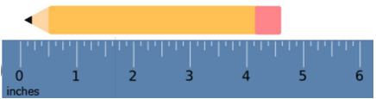

**Mathematical Reasoning:** Students may have difficulty determining which measurement unit is best for a contextual situation. For example, students may suggest that a large fish tank holds 4 gallons of water rather than 40 gallons of water. Similarly, they may suggest that a cup of juice is best measured by 2 pints rather than 1 cup. Providing opportunities for students to estimate and measure using containers of varying sizes and shapes will help students understand the magnitude of liquid volume measurements (cup, pint, quart, gallon).

**Mathematical Representations:** Students may struggle to measure the length of an object to the nearest inch or half-inch. They may count the inches starting from the end of the ruler, rather than from the zero mark. These students may benefit from constructing their own ruler from alternating colors of one-inch paper strips. Constructing a ruler in this way helps build conceptual understanding for measuring length. For example, in the image below, the end of the object is incorrectly lined up to the end of the ruler, rather than to the 0 mark on the ruler. This could result in students stating that the screwdriver is 4 inches long, rather than the correct response of 4 inches long, as shown in the image below.

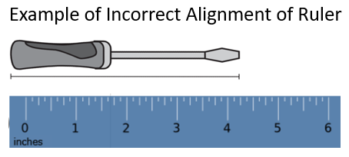

###### Concepts and Connections

Concepts

Analyzing and describing geometric objects in our world, the relationships and structures among them, or the space that they occupy can be used to classify, quantify, measure, or count one or more of their attributes.

Connections

* *Within the grade level/course*:
  + 3.NS.3 – The student will use mathematical reasoning and justification to represent and compare fractions (proper and improper) and mixed numbers with denominators of 2, 3, 4, 5, 6, 8, and 10), including those in context.
* *Vertical Progression*:
  + 2.MG.1 – The student will reason mathematically using standard units (U.S. Customary) with appropriate tools to estimate, measure, and compare objects by length, weight, and liquid volume to the nearest whole unit.
  + 4.MG.1 – The student will reason mathematically to solve problems, including those in context, that involve length, weight/mass, and liquid volume using U.S. Customary and metric units.

Across Content Areas [Theme – Modeling]

* *Science*: In Grade 3, students are expected to use models to demonstrate simple phenomena and natural processes.
  + 3.1e – The student will develop a model (e.g., diagram or simple physical prototype) to illustrate a proposed object, tool, or process.
  + 3.4b – The student will design and construct a model of a habitat for an animal with a specific adaptation.
  + 3.7c – The student will construct and interpret a model of the water cycle.
* *Computer Science*:
  + 3.CSY.1 – The student will model how computing devices within a computing system work.
    - d) Model how a computing system works including input and output, processors, and sensors.
  + 3.DA.3 – The student will create models that can represent a physical object or process.
    - a) Create a model to represent a physical object or process.
    - b) Identify how computing devices are used to create models.
    - c) Discuss the advantages and disadvantages of using computing devices to create models.

###### Resources to Support Local Curriculum

* A list of approved textbooks and instructional materials is posted on the VDOE [website](https://www.doe.virginia.gov/teaching-learning-assessment/k-12-standards-instruction/mathematics/2024-mathematics-textbooks).

### 3.MG.2

##### The student will use multiple representations to estimate and solve problems, including those in context, involving area and perimeter (in both U.S. Customary and metric units).

1. Students will demonstrate the following Knowledge and Skills:
2. Solve problems, including those in context, involving area:
   1. describe and give examples of area as a measurement in contextual situations; and
   2. estimate and determine the area of a given surface by counting the number of square units, describe the measurement (using the number and unit) and justify the measurement.
3. Solve problems, including those in context, involving perimeter:
   1. describe and give examples of perimeter as a measurement in contextual situations;
   2. estimate and measure the distance around a polygon (with no more than six sides) to determine the perimeter and justify the measurement; and
   3. given the lengths of all sides of a polygon (with no more than six sides), determine its perimeter and justify the measurement.

###### Understanding the Standard

* A polygon is a closed plane figure composed of at least three line segments that do not cross. A plane figure is any closed, two-dimensional shape.
* The area is the surface included within a plane figure. Area is measured by the number of square units needed to cover a surface or plane figure (e.g., the area of the book cover is 90 square inches).
* The unit of measure used to find the area is stated along with the numerical value (e.g., the area of the book cover is 90 square inches).
* Students should have opportunities to explore the concepts of area using hands-on experiences (e.g., filling or covering a polygon with tiles (square units) and counting the tiles to determine its area). Students should also have opportunities to explore area in contextual situations (e.g., painting a wall, mowing the lawn).
* Transparent grids or geoboards are useful tools for exploring the area of a figure.
* Students are not required to multiply to find the area of squares or rectangles in Grade 3. However, connections can be made to arrays and the area model of multiplication when using grids to measure the area of a square or rectangle to support future understanding of the area formula, which is addressed in Grade 4.
* The perimeter is the path or distance around any plane figure.
* Perimeter can be conceptualized as a linear measurement. This can be demonstrated by using a string to stretch around the edge of a figure and then measuring the length of the string.
* Opportunities to explore the concept of perimeter should involve hands-on experience (e.g., placing toothpicks (units) around a polygon and counting the number of toothpicks to determine its perimeter). Students should also explore the use of perimeter in contextual situations (e.g., putting ribbon around a picture, a fence around a yard).
* The unit of measure used to find the perimeter is stated along with the numerical value (e.g., the perimeter of the book cover is 38 inches).
* Students will benefit from experiences that include both measuring the length of sides as well as being given the side lengths to determine the perimeter of a polygon.

###### Skills in Practice

While the five process goals are expected to be embedded in each standard, the Skills in Practice highlight the most prevalent process goals in relation to the content presented.

**Mathematical Communication:** Students may confuse area and perimeter (see the images below). Students who have difficulty distinguishing between area and perimeter would benefit from more experiences finding the area and perimeter of given figures. Activities that require students to measure to determine the perimeter of a figure will reinforce the concept of perimeter. Activities that require students to physically cover a space with square units to determine the area of a figure will reinforce the concept of area. In addition, connecting these concepts to contexts in everyday life (e.g., If you want to make a frame for a picture you painted in art class, is it more helpful to know the perimeter or the area of the picture?) may help students conceptualize each type of measurement. When communicating about perimeter and area, encourage students to use accurate and appropriate mathematics vocabulary: units when describing perimeter (e.g., 16 inches, 36 units), and square units when describing area (e.g., 24 square inches, 108 square units). At this level, students are not expected to represent square units using an exponent of 2 (e.g., 24 ft.2).

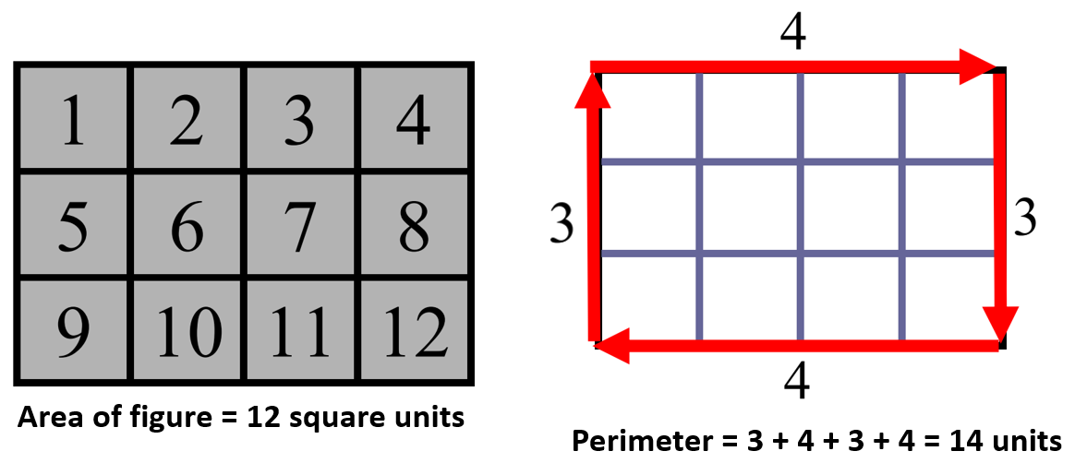

**Mathematical Connections:**

* Students should have opportunities to create two figures that have the same perimeter or two figures that have the same area. For example, in the image below, Figure A and Figure B each have an area of 6 square units, while Figure C and Figure D each have a perimeter of 12 units.

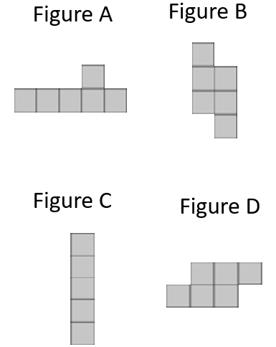

* When creating the figures, students may confuse area and perimeter. It is important that students have additional experience creating figures with a given area or perimeter. As they do so, they may begin to explore the idea that two figures can have the same perimeter but different areas, or the same area but different perimeters. This idea is formally addressed in Grade 4 using rectangles.

**Mathematical Representations:** Students may struggle to determine the perimeter when they are required to measure each side of a figure. They may misalign the ruler (e.g., starting at the end rather than starting at 0; see example under 3.MG.1 Mathematical Representationsunder Skills in Practice) or they may have difficulty adding the lengths of the sides. At this grade level, provided figures should have side lengths that are whole inches when students are asked to determine the perimeter.

###### Concepts and Connections

Concepts

Analyzing and describing geometric objects in our world, the relationships and structures among them, or the space that they occupy can be used to classify, quantify, measure, or count one or more of their attributes.

Connections

* *Within the grade level/course*:
  + 3.MG.1 – The student will reason mathematically using standard units (U.S. Customary and metric) with appropriate tools to estimate and measure objects by length, weight/mass, and liquid volume to the nearest half or whole unit.
* *Vertical Progression*:
  + There are no standards prior to Grade 3 that address area and perimeter. However, students’ measuring to the nearest inch in 2.MG.1 will be helpful as students measure and determine the perimeter of a figure.
  + 4.MG.3 – The student will use multiple representations to develop and use formulas to solve problems, including those in context, involving area and perimeter limited to rectangles and squares (in both U.S. Customary and metric units).

Across Content Areas

Reference 3.MG.1.

###### Resources to Support Local Curriculum

* A list of approved textbooks and instructional materials is posted on the VDOE [website](https://www.doe.virginia.gov/teaching-learning-assessment/k-12-standards-instruction/mathematics/2024-mathematics-textbooks).

### 3.MG.3

##### The student will demonstrate an understanding of the concept of time to the nearest minute and solve single-step contextual problems involving elapsed time in one-hour increments within a 12-hour period.

1. Students will demonstrate the following Knowledge and Skills:
2. Tell and write time to the nearest minute, using analog and digital clocks.
3. Match a written time (e.g., 4:38, 7:09, 12:51) to the time shown on analog and digital clocks to the nearest minute.
4. Solve single-step contextual problems involving elapsed time in one-hour increments, within a 12-hour period (within a.m. or within p.m.) when given:
   1. the starting time and the ending time, determine the amount of time that has elapsed;
   2. the starting time and amount of elapsed time in one-hour increments, determine the ending time; or
   3. the ending time and the amount of elapsed time in one-hour increments, determine the starting time.

###### Understanding the Standard

* Time passes in equal increments (e.g., seconds, minutes, or hours).
* The use of an analog clock facilitates the understanding of time relationships between minutes and hours, and hours and days.
* There are 60 minutes in one hour, and 24 hours in one day.
* The use of a demonstration clock with gears ensures that the positions of the hour hand and the minute hand are always precise.
* Time is usually described using a 12-hour clock, so two times in the day have the same numeric name. The use of a.m. (before noon) and p.m. (after noon) provides a distinction between the two times.
* Elapsed time is the amount of time that has passed between two given times.
* Elapsed time should be modeled and demonstrated using geared analog clocks and timelines.The images below could be used to represent the following situation: Soccer practice started at 3:35p.m. and lasted for 2 hours. What time did soccer practice end?

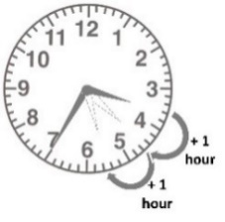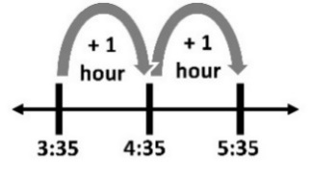

* Elapsed time can be found by counting on from the starting time or counting back from the ending time.
* In Grade 4, students will experience elapsed time problems that require crossing from a.m. to p.m. (e.g., the length of the school day) or from p.m. to a.m. (e.g., number of hours of sleep).

###### Skills in Practice

While the five process goals are expected to be embedded in each standard, the Skills in Practice highlight the most prevalent process goals in relation to the content presented.

**Mathematical Problem Solving:** Grade 3 is students’ first formal introduction to elapsed time. Students need many opportunities to solve three types of elapsed time problems: determining the starting time, determining the ending time, and determining the amount of elapsed time. Determining the start time of an event when given the amount of elapsed time and the ending time of an event, may be difficult for students as they must count backward to determine the start time. Students may benefit from the use of timelines or graphic organizers to solve elapsed time problems. Consider the example below.

Julio’s baseball game ended at 7:12p.m. The baseball game was three hours long. What time did the baseball game begin?

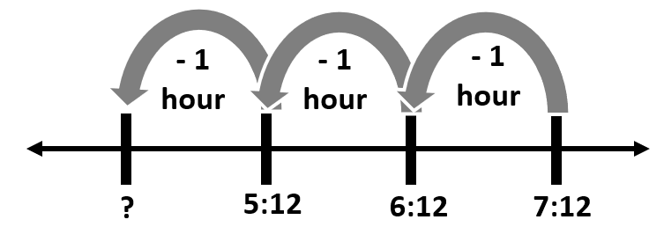

Because this problem requires students to work backward from the given end time to determine the missing start time, students could draw a timeline like the one above and count backwards one hour at a time for three hours, resulting in a starting time of 4:12pm.

**Mathematical Representations:** Students may have difficulty determining the time on an analog clock. For example, given the analog clock below, students could make the following errors:

* + confusing the hour hand and the minute hand, resulting in reading the time as 8:04. For students who confuse the hour and minute hand, opportunities to begin with only the hour hand may be beneficial.
  + reading the minute hand incorrectly, and not counting by 5s, resulting in reading the time as 12:08 (the nearest labeled number to the minute hand). These students would benefit from additional opportunities to develop their skills in counting by fives to the nearest number on the clock and then counting on by ones as needed.
  + incorrectly reading the time as it approaches the next hour, resulting in reading the time as 1:42. These students have difficulty understanding how the hour hand moves in relation to the movement of the minute hand. The use of a “geared clock” would benefit these students as it illustrates how the position of the hour hand changes as the minute hand progresses around the clock.

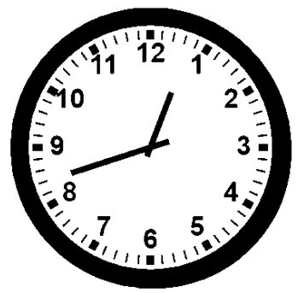

###### Concepts and Connections

Concepts

Analyzing and describing geometric objects in our world, the relationships and structures among them, or the space that they occupy can be used to classify, quantify, measure, or count one or more of their attributes.

Connections

* *Within the grade level/course*:
  + 3.CE.1 – The student will estimate, represent, solve, and justify solutions to single-step and multistep problems, including those in context, using addition and subtraction with whole numbers where addends and minuends do not exceed 1,000.
  + 3.PFA.1 – The student will identify, describe, extend, and create increasing and decreasing patterns (limited to addition and subtraction of whole numbers), including those in context, using various representations.
* *Vertical Progression*:
  + 2.MG.2 – The student will demonstrate an understanding of the concept of time to the nearest five minutes, using analog and digital clocks.
  + 4.MG.2 – The student will solve single-step and multistep contextual problems involving elapsed time (limited to hours and minutes within a 12-hour period).

Across Content Areas

Reference 3.MG.1.

###### Resources to Support Local Curriculum

* A list of approved textbooks and instructional materials is posted on the VDOE [website](https://www.doe.virginia.gov/teaching-learning-assessment/k-12-standards-instruction/mathematics/2024-mathematics-textbooks).
* Hoppin’ on the Elapsed Timeline Exemplar Mathematics Instructional Plan ([Word](https://www.doe.virginia.gov/home/showpublisheddocument/51757/638530875109770000) | [PDF](https://www.doe.virginia.gov/home/showpublisheddocument/51759/638530875610200000))
* Where Did the Time Go? Exemplar Mathematics Instructional Plan ([Word](https://www.doe.virginia.gov/home/showpublisheddocument/51761/638398745937130000) | [PDF](https://www.doe.virginia.gov/home/showpublisheddocument/51763/638398745942600000))

### 3.MG.4

##### The student will identify, describe, classify, compare, combine, and subdivide polygons.

1. Students will demonstrate the following Knowledge and Skills:
2. Describe a polygon as a closed plane figure composed of at least three line segments that do not cross.
3. Classify figures as polygons or not polygons and justify reasoning.
4. Identify and describe triangles, quadrilaterals, pentagons, hexagons, and octagons in various orientations, with and without contexts.
5. Identify and name examples of polygons (triangles, quadrilaterals, pentagons, hexagons, octagons) in the environment.
6. Classify and compare polygons (triangles, quadrilaterals, pentagons, hexagons, octagons).
7. Combine no more than three polygons, where each has three or four sides, and name the resulting polygon (triangles, quadrilaterals, pentagons, hexagons, octagons).
8. Subdivide a three-sided or four-sided polygon into no more than three parts and name the resulting polygons.

###### Understanding the Standard

* The study of polygons is rich with geometry vocabulary. At this level, students should be introduced to the following vocabulary and should be encouraged to use it accurately during instruction:
* A polygon is a closed plane figure composed of at least three line segments that do not cross.
* A point is an exact location in space. It has no length, width, or height.
* A line is a collection of points extending indefinitely in both directions. It has no endpoints.
* A line segment is part of a line. It has two endpoints and includes all the points between and including those endpoints.
* A ray is a part of a line. It has one endpoint and extends indefinitely in one direction.
* A vertex is a point at which two or more lines, line segments, or rays meet to form an angle.
* An angle is formed by two rays that share a common endpoint called the vertex. Angles are found wherever lines or line segments intersect.
* The table below shows examples of geometric figures.

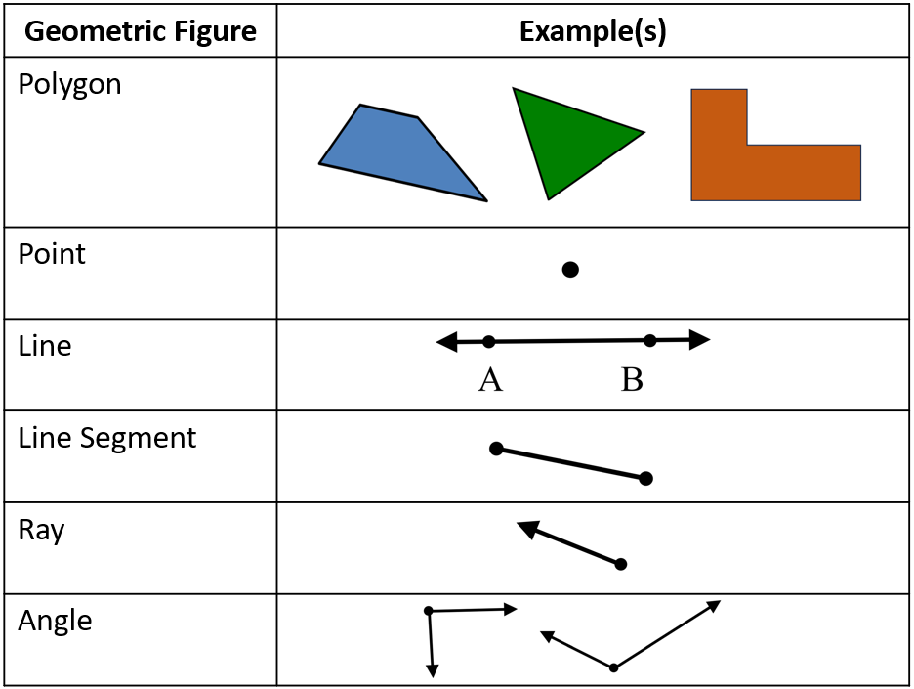

* Polygons are named according to the number of sides:
* triangle is a three-sided polygon;
* quadrilateral is a four-sided polygon;
* pentagon is a five-sided polygon;
* hexagon is a six-sided polygon; and
* octagon is an eight-sided polygon.
* Examples of polygons are shown in the table below.

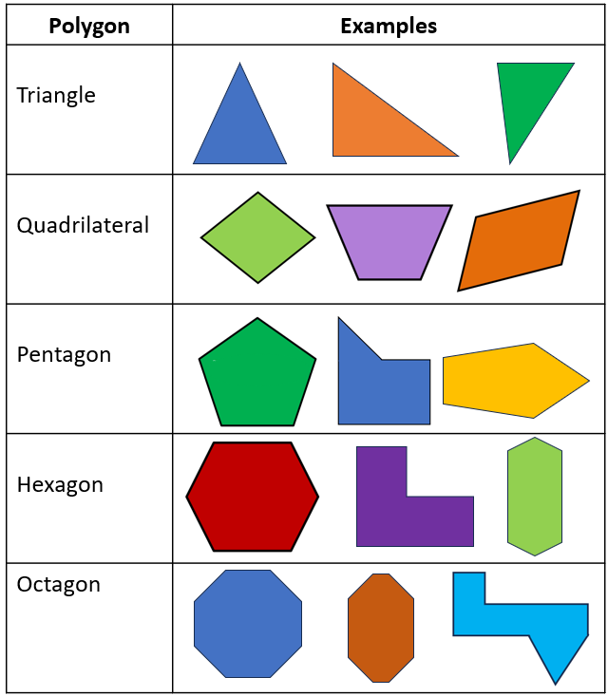

* Students in Grade 3 identify four-sided polygons as quadrilaterals but may also recognize rectangles and squares as names for specific quadrilaterals. In Grade 4, students will learn to name and classify other quadrilaterals.
* Polygons may be described by their attributes. Attributes of a polygon include:
* having congruent or noncongruent sides;
* angle measures (e.g., right angles);
* number of sides and angles;
* area; and
* perimeter.
* A regular polygon has congruent sides and angles. An irregular polygon has sides and angles of different lengths and measures.

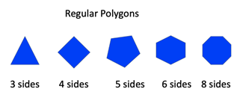

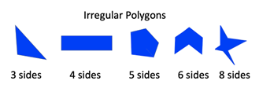

* Students should have experiences with both regular and irregular polygons and have opportunities to notice patterns with regular polygons. For example, as the number of sides increases, the closer to a circle the figure becomes. Similarly, as the number of sides increases, the measure of each angle increases. While students in Grade 3 are not expected to measure the angles of polygons, they may notice that the angles become “wider” or “more open” as the number of sides increases.
* Polygons retain their shape despite changes in orientation or transformations. It is important to present polygons in a variety of spatial orientations so that students do not develop the common misconception that polygons must have one side parallel to the bottom of the page on which they are printed.
* A composite or compound figure is any figure that is made up of two or more geometric shapes.
* When subdividing, or decomposing, polygons, students develop an understanding of the conservation of area (i.e., the area of a figure does not change when it is subdivided, as long as no parts are removed). Concrete materials can be used to divide a polygon into familiar figures. (e.g., pattern blocks, tangrams, geoboards, grid paper, paper folding).
* When combining and subdividing polygons, both regular and irregular polygons can be used or created.
* When combining and subdividing polygons, students should discuss changes in the number of sides, perimeter, area, etc. between the original and resulting polygons.

###### Skills in Practice

While the five process goals are expected to be embedded in each standard, the Skills in Practice highlight the most prevalent process goals in relation to the content presented.

**Mathematical Communication:** When given a figure, students may have difficulty determining what type of polygon the figure represents, particularly when the figure is irregular or concave. Students may struggle to accurately count the number of sides or may name the figure based on the way it looks, rather than counting the sides. Additionally, students may confuse the prefixes when naming polygons. Connecting the prefixes to other words that students are familiar with may help reinforce the meaning of the polygon prefixes (e.g., the prefix *tri*- in triangle can be connected to a tricycle, which has three wheels; the prefix *oct*- in octagon can be connected to an octopus, which has eight legs). Students will benefit from using and hearing the vocabulary used to name polygons during classroom discussion. Incorporating and encouraging the use of accurate vocabulary is a meaningful way to provide practice with the prefixes used to name polygons.

**Mathematical Representations:** When working with polygons, students may suggest that open figures, figures with curves or crossed segments, or three-dimensional figures are examples of polygons (see non-examples of polygons below). Opportunities to engage with various examples and non-examples of polygons will benefit students as they classify figures as polygons or not polygons. Games such as “What’s My Rule?” can be used to reinforce the definition of polygons. To play, the teacher selects a few shapes that fit a pre-determined rule. Without knowing the rule, the student selects a different shape that they believe fits the rule and places it in the group. Shapes that fit the rule remain in the group, but the student should remove any shapes that do not fit the rule. The student should describe the rule after sorting all the shapes.

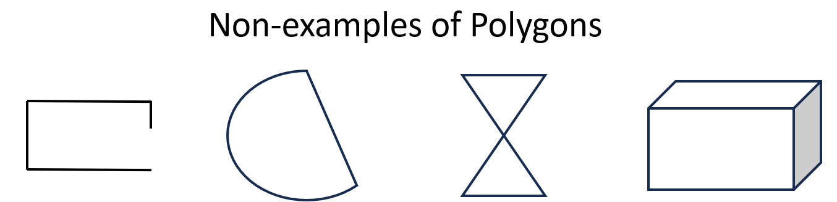

###### Concepts and Connections

Concepts

Analyzing and describing geometric objects in our world, the relationships and structures among them, or the space that they occupy can be used to classify, quantify, measure, or count one or more of their attributes.

Connections

* *Within the grade level/course*:
  + 3.PFA.1 – The student will identify, describe, extend, and create increasing and decreasing patterns (limited to addition and subtraction of whole numbers), including those in context, using various representations.
* *Vertical Progression*:
  + 2.MG.3 – The student will identify, describe, and create plane figures (including circles, triangles, squares, and rectangles) that have at least one line of symmetry and explain its relationship with congruency.
  + 2.MG.4 – The student will describe, name, compare, and contrast plane and solid figures (circles/spheres, squares/cubes, and rectangles/rectangular prisms).
  + 4.MG.4 – The student will identify, describe, and draw points, rays, line segments, angles, and lines, including intersecting, parallel, and perpendicular lines.
  + 4.MG.5 – The student will classify and describe quadrilaterals (parallelograms, rectangles, squares, rhombi, and/or trapezoids) using specific properties and attributes.
  + 4.MG.6 – The student will identify, describe, compare, and contrast plane and solid figures according to their characteristics (number of angles, vertices, edges, and the number and shape of faces), with and without models.

Across Content Areas

Reference 3.MG.1.

###### Resources to Support Local Curriculum

* A list of approved textbooks and instructional materials is posted on the VDOE [website](https://www.doe.virginia.gov/teaching-learning-assessment/k-12-standards-instruction/mathematics/2024-mathematics-textbooks).

## Probability and Statistics

In K-12 mathematics, probability and statistics introduce students to the concepts of uncertainty and data analysis. Probability involves understanding the likelihood of events occurring, often using concepts such as experiments, outcomes, and the use of fractions and percentages. The formal study or probability begins in Grade 4. Statistics focuses on collecting, organizing, and interpreting data and includes a basic understanding of graphs and charts. Probability and statistics help students analyze and make sense of real-world data and are fundamental for developing critical thinking skills and making informed decisions using data.

In Grade 3, students understand the world can be investigated through posing questions and collecting, representing, analyzing, and interpreting data to describe and predict events and real-world phenomena. At this grade level, students will apply the data cycle (formulate questions; collect or acquire data; organize and represent data; and analyze data and communicate results) with a focus on pictographs and bar graphs.

### 3.PS.1

##### The student will apply the data cycle (formulate questions; collect or acquire data; organize and represent data; and analyze data and communicate results) with a focus on pictographs and bar graphs.

1. Students will demonstrate the following Knowledge and Skills:
2. Formulate questions that require the collection or acquisition of data.
3. Determine the data needed to answer a formulated question and collect or acquire existing data (limited to 30 or fewer data points for no more than eight categories) using various methods (e.g., polls, observations, tallies).
4. Organize and represent a data set using pictographs that include an appropriate title, labeled axes, and key. Each pictograph symbol should represent 1, 2, 5 or 10 data points.
5. Organize and represent a data set using bar graphs with a title and labeled axes, with and without the use of technology tools. Determine and use an appropriate scale (increments limited to multiples of 1, 2, 5 or 10).
6. Analyze data represented in pictographs and bar graphs, and communicate results orally and in writing:
   1. describe the categories of data and the data as a whole (e.g., data were collected on preferred ways to cook or prepare eggs - scrambled, fried, hard boiled, and egg salad);
   2. identify parts of the data that have special characteristics, including categories with the greatest, the least, or the same (e.g., most students prefer scrambled eggs);
   3. make inferences about data represented in pictographs and bar graphs;
   4. use characteristics of the data to draw conclusions about the data and make predictions based on the data (e.g., it is unlikely that a third grader would like hard boiled eggs); and
   5. solve one- and two-step addition and subtraction problems using data from pictographs and bar graphs.

###### Understanding the Standard

* Students should explore the entire data cycle with a question and set of data that has been collected or acquired. Student reflection should occur throughout the data cycle. The data cycle includes the following steps: formulating questions to be explored with data, collecting or acquiring data, organizing and representing data, and analyzing and communicating results.

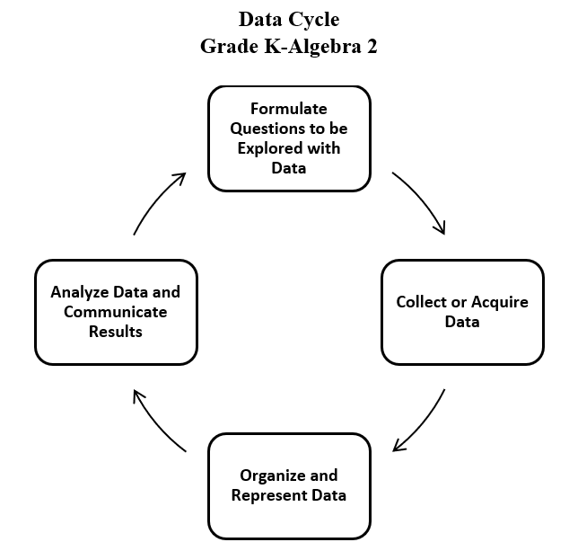

* Formulating questions for investigations is student-generated at this level. For example: What is the cafeteria lunch preferred by students in the class when four lunch options are offered?
* Data are pieces of information collected about people or things. The primary purpose of collecting data is to answer questions. The primary purpose of interpreting data is to inform decisions (e.g., which type of clothing to pack for a trip based on a weather graph or which type of lunch to serve based on class favorites).
* Investigations involving data should occur frequently and relate to students’ experiences, interests, and environment. Contexts should ensure that students can collect or have access to all necessary data. In Grade 3, students are encouraged to explore data sets larger than their classroom (e.g., grade level, school) and evaluate whether a given data set is representative of larger or smaller populations.
* While probability is not formally introduced until Grade 4, students may generate data from experiments using materials such as two-color counters, spinners, and number cubes. The possible outcomes from these experiments are the data categories.
* Students may also use data that has been acquired from resources (e.g., a list of student birthdays, transportation lists, weather data, lunchroom data, media center data, data from a previously conducted experiment).
* Technology tools (e.g., graphing tools, spreadsheets) can be used to collect, organize, and visualize data. These tools support progression to analysis of data in a more efficient manner.
* The purpose of a graph is to represent data gathered to answer a question. Different types of graphs can be used to display categorical data. The way data are displayed often depends on what someone is trying to communicate.
* A pictograph is used to show frequencies and compare categories. Pictographs can be misleading or challenging to read because a symbol can represent more than one data point (see example below).

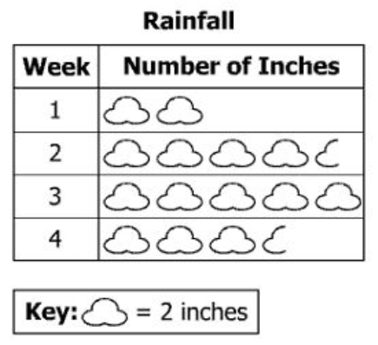

* A key is provided for the symbol in a pictograph when the symbol represents more than one piece of data (e.g.,  Image of stick figure represents five people in a graph). The key is used in a graph to assist in the analysis of the displayed data. One-half of a symbol represents one-half of the value of the symbol being used, as indicated in the key.
* Students’ prior knowledge and work with skip counting will help them to interpret the data in a pictograph.
* Pictographs are most often defined as a pictorial representation of numerical data. The focus of instruction should be placed on reading and using the key when analyzing the graph.
* A bar graph is used to show comparisons and to organize the data for larger data sets. The scale of a bar graph allows for easy representation of all data counts.
* Bar graphs are used to compare counts of different categories (categorical data). Using grid paper helps to increase accuracy in graphs. Technology can also be used to create bar graphs (e.g., spreadsheets, graphing programs, websites).
* At this level, a bar graph uses horizontal or vertical parallel bars to represent counts for up to 8 categories. One bar is used for each category with the length of the bar representing the count for that category. There is space before, between, and after the bars.
* The axis displaying the scale, representing the count for the categories, should begin at zero and extend one increment above the greatest recorded piece of data. Grade 3 students collect data that is recorded in increments of whole numbers, limited to multiples of 1, 2, 5, or 10. See the examples of bar graphs below.

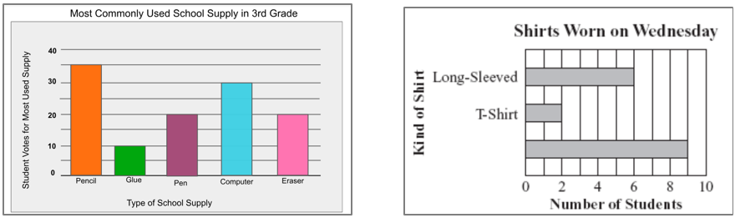

* Each axis should be labeled, and the graph should be given a title.  At this level students are not expected to use the word axis.
* Statements about a graph should express predictions based on the analysis and interpretation of the characteristics of data in graphs (e.g., the lunchroom may run out of pizza since that is the lunch students have liked the most).
* The information displayed in different graphs may be examined to determine how data are or are not related, differences between characteristics (comparisons), trends that suggest what new data might be like (predictions), and/or “what could happen if” (inferences).
* Exposure to the analysis of traditional and nontraditional data representations supports the development of data literacy. Examples of nontraditional data representations may include word clouds, frequency graphs, quadrant graphs, etc.
* The data cycle can be used to make connections between mathematics and other disciplines including English, social studies, or science.
  + Sample Connections to English Standards of Learning
    - Who is your favorite author?
    - What is your favorite story that was read in class?
    - What is your favorite type of book to read?
  + Sample Connections to History and Social Science Standards of Learning
    - How do you demonstrate good citizenship?
    - Which is your favorite ancient civilization?
    - What resources (natural, human, capital) are used throughout the day?
    - Who is your favorite famous American studied in social studies class?
    - Taking part of the voting process when making classroom decisions
  + Sample Connections to Science Standards of Learning
    - Gather data on which simple machines are used throughout the day
    - Gather data on whether a solid dissolves in water or not
    - Gather data on natural resources used throughout the day
* Students would benefit from exploring previously taught graphical representations when justifying how to best represent data clearly and accurately. Comparing different types of representations (charts and graphs) provides an opportunity to learn how different graphs can show different things about the same data. Discussions around what information different graphs representing the same data provides are beneficial for determining which graphical representation best represents the data.

###### Skills in Practice

While the five process goals are expected to be embedded in each standard, the Skills in Practice highlight the most prevalent process goals in relation to the content presented.

**Mathematical Communication:** As Grade 3 students engage in the data cycle, they may struggle to formulate questions that require the collection of data. Teacher support will be necessary to help students distinguish between questions that require data to answer and questions that do not require data to answer. For example, “Do we have art class today?” is a question that does not require data to answer; the answer is simply yes or no. Questions that require the collection of data could include anything that involves surveying other students, measuring, or counting and quantifying amounts (see examples below).

* Questions that require surveying
  + What is your favorite activity to do during recess?
  + Which cafeteria lunch is preferred by students in class?
* Questions that require measuring
  + How much rain did we get each day this month?
  + If a t-shirt factory wanted to make shirts for our class, what length sleeves should they make?
* Questions that require counting and quantifying
  + How was the weather this month (sunny, rainy, cloudy)?
  + The librarian is going to order new books for the library. Which authors should she include in this purchase?

**Mathematical Representations:** In Grade 2, students had experience with pictographs where the key may have represented more than one object, and bar graphs where the scale may have increased by more than one number each time. In Grade 3, some students may continue to have difficulty analyzing and interpreting such graphs. Some common errors include:

* counting each object or bar by one instead of using the key or scale. These students would benefit from experiences where they collect their own data and then translate it to a pictograph or bar graph using a key or scale beyond one.
* incorrectly counting by twos, fives, or tens to determine the amount represented in each category. These students would benefit from additional experiences with skip counting.
* incorrectly representing a category that has an odd number of objects using a key or scale that counts by twos. These students would benefit from additional experiences collecting data using a table or chart and then creating a pictograph where each symbol represents more than one data element.

###### Concepts and Connections

Concepts

Investigating the world through posing questions, collecting data, organizing and representing data, and analyzing data and communicating results can be used to describe and predict events and real-world phenomena.

Connections

* *Within the grade level/course*:
  + 3.CE.1 – The student will estimate, represent, solve, and justify solutions to single-step and multistep problems, including those in context, using addition and subtraction with whole numbers where addends and minuends do not exceed 1,000.
* *Vertical Progression*:
  + 2.PS.1 – The student will apply the data cycle (pose questions; collect or acquire data; organize and represent data; and analyze data and communicate results) with a focus on pictographs and bar graphs.
  + 4.PS.1 – The student will apply the data cycle (formulate questions; collect or acquire data; organize and represent data; and analyze data and communicate results) with a focus on line graphs.

Across Content Areas [Theme – Using Data]

* *Science:* 
  + 3.1b – The student will, with guidance, plan and conduct investigations.
  + 3.1c – The student will organize and represent data in pictographs or bar graphs.
* *Computer Science*:
  + 3.DA.1 – The student will gather, store, and organize data to evaluate trends and identify patterns using a computing device.
    - a) Formulate questions that require the collection or acquisition of data
    - b) Gather, organize, sort, and store data.
    - c) Examine a labeled dataset to identify potential problems within the data
    - d) Discuss how data discrepancies or problems impact predictions and results.
    - e) Draw conclusions and make predictions based on observed data.
  + 3.DA.2 – The student will create and evaluate data representations and conclusions.
    - a) Create charts and graphs based on data collection.
    - b) Analyze data to identify patterns, draw conclusions, and make predictions.

Across Content Areas [Theme – Graphing]

* *Science*: Depending on the data collected in an investigation, students may use graphs to visualize the data.
  + 3.1c – The student will organize and represent data in pictographs or bar graphs; and read, interpret, and analyze data represented in pictographs and bar graphs.
* *Computer Science*:
  + 3.CSY.1 – The student will model how computing devices within a computing system work.
    - d) Model how a computing system works including input and output, processors, and sensors.
  + 3.DA.3 – The student will create models that can represent a physical object or process.
    - a) Create a model to represent a physical object or process.
    - b) Identify how computing devices are used to create models.
    - c) Discuss the advantages and disadvantages of using computing devices to create models.
* *Digital Learning Integration:* 
  + 3-5 CT.B. Students select and use appropriate technologies to represent data, which will be used for interpretation and evidence-based decision making.

###### Resources to Support Local Curriculum

* A list of approved textbooks and instructional materials is posted on the VDOE [website](https://www.doe.virginia.gov/teaching-learning-assessment/k-12-standards-instruction/mathematics/2024-mathematics-textbooks).
* Data Cycle Teacher Resource ([PPT](https://www.doe.virginia.gov/home/showdocument?id=52075&t=638411641456670000) | [PDF](https://www.doe.virginia.gov/home/showdocument?id=52073&t=638411641450700000))

## Patterns, Functions, and Algebra

In K-12 mathematics, the patterns, functions, and algebra strand focuses on the recognition, description, and analysis of patterns, functions, and algebraic concepts. Students develop an understanding of mathematical relationships and represent these using symbols, tables, graphs, and rules. In later grades, students use models as they solve equations and inequalities and develop an understanding of functions. This strand is designed to develop students’ algebraic thinking and problem-solving skills, laying the foundation for more advanced mathematical concepts.

In Grade 3, students understand that relationships can be described, and generalizations can be made using patterns and relations. At this grade level, students will identify, describe, extend, and create increasing and decreasing patterns using various representations.

### 3.PFA.1

##### The student will identify, describe, extend, and create increasing and decreasing patterns (limited to addition and subtraction of whole numbers), including those in context, using various representations.

1. Students will demonstrate the following Knowledge and Skills:
2. Identify and describe increasing and decreasing patterns using various representations (e.g., objects, pictures, numbers, number lines).
3. Analyze an increasing or decreasing pattern and generalize the change to extend the pattern or identify missing terms using various representations.
4. Solve contextual problems that involve identifying, describing, and extending patterns.
5. Create increasing and decreasing patterns using objects, pictures, numbers, and number lines.
6. Investigate and explain the connection between two different representations of the same increasing or decreasing pattern.

###### Understanding the Standard

* Developing fluency and flexibility in identifying, describing, and extending patterns is fundamental to mathematics, particularly algebraic reasoning.
* The use of materials to extend patterns permits an analysis and generalization of change that supports experimentation or problem-solving approaches.
* Growing patterns involve a progression from term to term, which make them more challenging for students than repeating patterns. Growing patterns can increase or decrease. Students in Grade 2 worked with repeating patterns and increasing patterns. At this level, students will deepen their work with increasing and will be introduced to decreasing patterns.
* Increasing and decreasing patterns may be represented in various ways, including dot patterns, staircases, geometric shapes, pictures, number lines, hundreds charts, numeric sequences, etc.
* When students analyze an increasing or decreasing pattern, they identify what changes and what stays the same from term to term. This begins the process of generalization to determine what comes next in a pattern which leads to the foundation of algebraic reasoning. The process of looking for a generalization or relationship (e.g., rule) will provide students with information about how the pattern changes and allows them to identify apparent features of the pattern that are not explicit in the identified relationship. In many patterns, the change can be described as an increase or decrease by a constant value.
* In certain numeric patterns (*arithmetic sequences*), students will be able to determine the difference, called the *common difference*, between each succeeding number (e.g., term) in order to determine what is added to or subtracted from each previous number to obtain the next number. Students do not need to use the phrases *arithmetic sequence* or *common difference* at this level.
* In Grade 3, numeric patterns will be limited to addition and subtraction of whole numbers.
* Sample numeric patterns include:
  + 6, 9, 12, 15, 18, … (increasing pattern);
  + 1, 2, 4, 7, 11, 16, … (increasing pattern); and
  + 20, 18, 16, 14, … (decreasing pattern).
* Sample geometric figure patterns include:



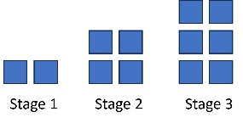

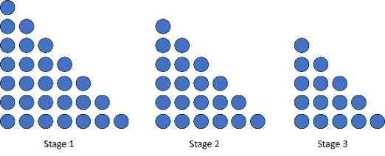

* Tools such as hundred charts, pattern blocks, color tiles, number lines, calculators, toothpicks, etc. facilitate experimentation and problem-solving, allowing students to create patterns and make connections between different representations of the same pattern (transfer).
* Sample increasing and decreasing pattern transfers include:
  + 2, 5, 8, 11, 14... which has the same structure as 4, 7, 10, 13, 16...
  + 50, 45, 40, 35... which has the same structure as 63, 58, 53, 48...
  + blue, red, blue, blue, red, blue, blue, blue, red… which has the same structure as …
* During student exploration of patterns, there are many opportunities to make explicit connections to other mathematics content, including:
  + even and/or odd numbers (e.g., counting a collection by 2 vs. counting by 3);
  + geometric figures with increasing numbers of sides (e.g., triangle, quadrilateral, pentagon...);
  + multiplication, skip counting, and repeated addition or subtraction (e.g., 0, 3, 6, 9…); and
  + place value (e.g., adding or subtracting 10 or 100).

###### Skills in Practice

While the five process goals are expected to be embedded in each standard, the Skills in Practice highlight the most prevalent process goals in relation to the content presented.

**Mathematical Reasoning:** Students may have difficulty extending a pattern beyond the next term. For example, consider the pattern below. If students are asked to find the ninth number, they may incorrectly respond 22 (because it is the next number after 21) or 25 (because they recognized the pattern but wrote the seventh term rather than the ninth term). Students who make these errors would benefit from additional experiences where they must analyze a pattern to see how each term changes and then extend a pattern beyond the next term.

Image shows a sequence of numbers: one, five, nine, thirteen, seventeen, twenty-one

**Mathematical Connections:** Patterns are present in many other areas of mathematics and students should be encouraged to see the connections between patterns and other content. For example, when studying polygons, a pattern like the one below could be used. Each term is increasing the number of sides by one, and the next term would be a hexagon. (If extending this pattern beyond one additional term, students could be introduced to the term heptagon, however they are not responsible for identifying or classifying figures as heptagons.)



Similarly, when working with multiplication and division, number patterns will be a focus. In the early stages of learning multiplication and division, students will understand that multiplication can be represented by skip counting forwards (e.g., a student may solve 6 × 3 by skip counting six groups of three: 3, 6, 9, 12, 15, 18). Patterns will also be evident in place value, fractions, measurement, and telling time.

###### Concepts and Connections

Concepts

Relationships are described and generalizations are made using patterns, relations, and functions.

Connections

* *Within the grade level/course*:
  + 3.NS.1 – The student will use place value understanding to read, write, and determine the place and value of each digit in a whole number, up to six digits, with and without models.
  + 3.CE.1 – The student will estimate, represent, solve, and justify solutions to single-step and multistep problems, including those in context, using addition and subtraction with whole numbers where addends and minuends do not exceed 1,000.
  + 3.MG.3 – The student will demonstrate an understanding of the concept of time to the nearest minute and solve single-step contextual problems involving elapsed time in one-hour increments within a 12-hour period.
  + 3.MG.4 – The student will identify, describe, classify, compare, combine, and subdivide polygons.
* *Vertical Progression*:
  + 2.PFA.1 – The student will describe, extend, create, and transfer repeating and increasing patterns (limited to addition of whole numbers) using various representations.
  + 4.PFA.1 – The student will identify, describe, extend, and create increasing and decreasing patterns (limited to addition, subtraction, and multiplication of whole numbers), including those in context, using various representations.

Across Content Areas [Theme – Numbers, Number Sense, and Patterns]

* *Science:* 
  + 3.7c – The student will investigate and understand that there is a water cycle and water is important to life on earth, including the key idea that the water cycle involves specific processes.
* *Computer Science*:
  + 3.AP.1 – The student will apply computational thinking to design algorithms to extend patterns, processes, or components of a problem.
    - a) Identify a pattern in an algorithm, process, or a problem
    - b) Decompose a problem or task into a subset of smaller problems.
    - c) Design an algorithm to extend either a pattern, process, or component of a problem.
  + 3.DA.2 – The student will create and evaluate data representations and conclusions.
    - b) Analyze data to identify patterns, draw conclusions, and make predictions.

###### Resources to Support Local Curriculum

* A list of approved textbooks and instructional materials is posted on the VDOE [website](https://www.doe.virginia.gov/teaching-learning-assessment/k-12-standards-instruction/mathematics/2024-mathematics-textbooks).